 | Do not manually edit this table.
Title | Arts and Society
Keywords | Arts, Society, Semiotics, Marxism, Feminism, Dance
Description | Tasks involve some reading, listening, watching and reflecting on the role of the arts in society. Year 1 undergraduates, Higher Education Level 4.
Version | 03/1/2013
Status | final
Cost | no
Restrictions | yes
Description | Creative Commons Attribution-NonCommercial-ShareAlike 2.0 Licence.
Author | Inma Álvarez and Melissa Blanco-Borelli
Organisation | University of Surrey
Date | 2012

Introduction to the online tasks

Here you will find a set of tasks to help you prepare for your weekly lessons in this module. The tasks include selected readings (some available online) and viewings with questions, reflective activities and other online collaborative activities for which you will be using forums and walls. Each task will take you between one hour and a half and two hours to complete.

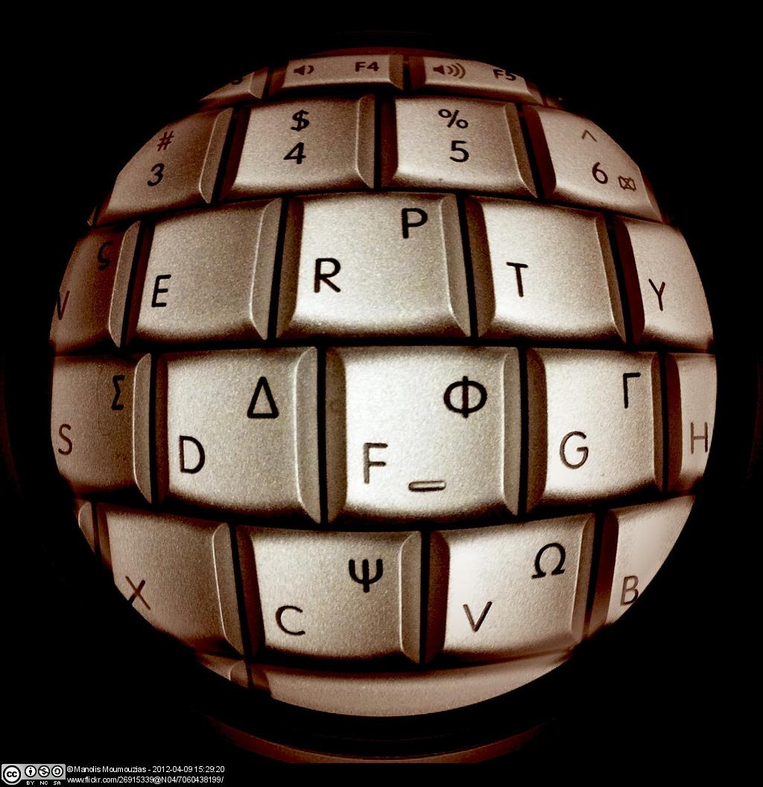

Some of this independent and collaborative work will be further exploited during your lessons. Please make sure you come ready for your lesson by completing the relevant task beforehand.

Saving your answers

If you wish to save your answers to the e-learning tasks and keep this information for further use, we suggest that once you have completed your answers on a page and seen the feedback, before you continue, save them in your computer (or in a pen drive) as a pdf by using the "Print to File" option.

To do this, right click on the page you would like to save and choose “Print”.
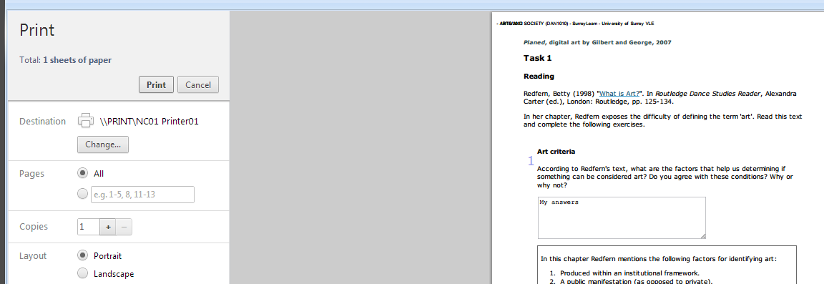

From the options on the left, make sure your Destination is “Save as PDF”.
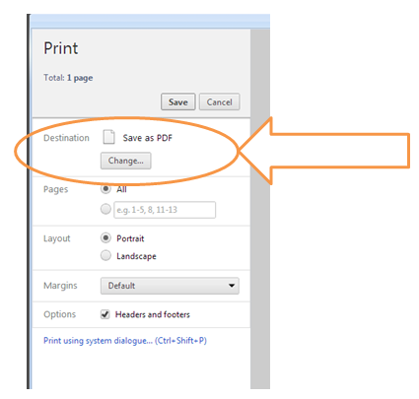

What is art? What is society?

In this introductory lecture we will think about the concept of art and how it shapes cultural production. We will question notions of aesthetics and how cultural ideologies play an important role in setting up the ways in which we look at, judge, and acknowledge art.
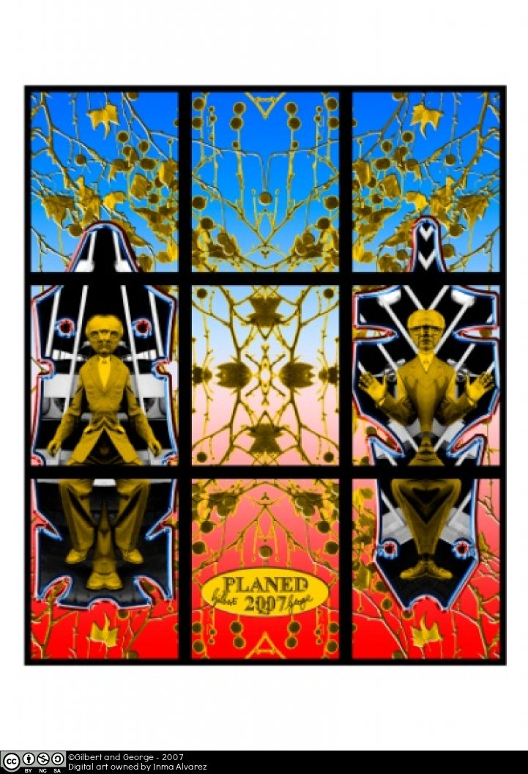

Task 1
Reading

Redfern, Betty (1998) "What is Art?" (opens in a new window). In Routledge Dance Studies Reader, Alexandra Carter (ed.), London: Routledge, pp. 125-134.

In her chapter, Redfern exposes the difficulty of defining the term ‘art’. Read this text and complete the following exercises.

 | Textentry1
Title | Art criteria
Text | According to Redfern’s text, what are the factors that help us determine if something can be considered art? Do you agree with these conditions? Why or why not?
Feedback | In this chapter Redfern mentions the following factors for identifying art:  - Produced within an institutional framework.  - A public manifestation (as opposed to private).  - The production of sensuous or tangible works.  - Something that derives from and contributes to culture.  - A social activity.  - Something produced intentionally under the concept of art.  - Something produced against a background of inherited standards and traditions.  - Something that demands new kinds of responses and behaviours.

 | Textentry1
Title | Examples of art
Text | Find on the internet an example of something you consider art and justify it according to the factors mentioned by Redfern.
Feedback | This is an open response. Here you have a sample answer.  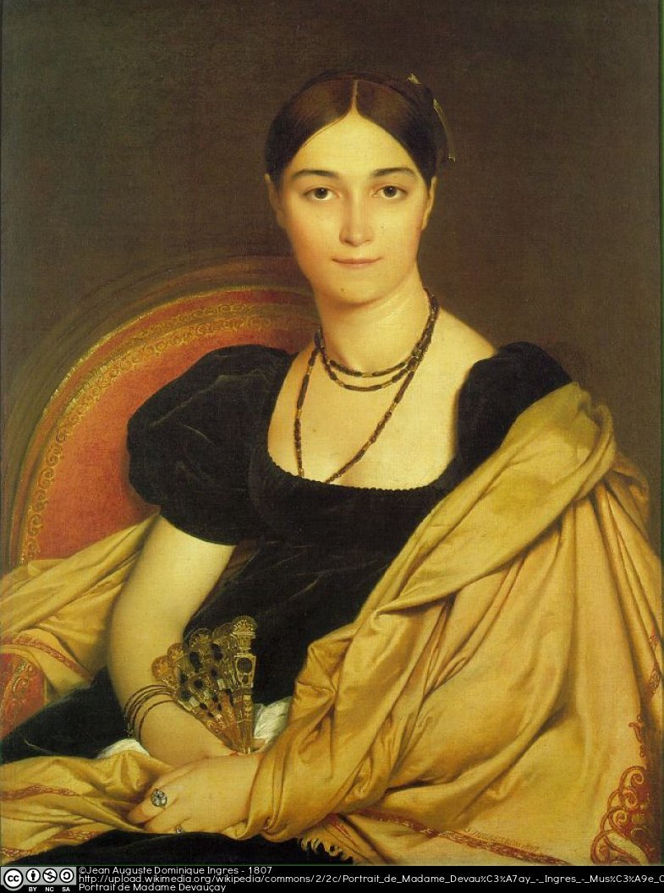  This painting is an example of art because it was intentionally done by a well-known artist, Jean August Ingres, who produced this work in 1807 following the art tradition of portrait painting of the upper-class. For this painting he uses standard artistic materials such as oil on canvas but in a reduced chromatic range displaying a great influence by previous painters of the Western cultural tradition such as Rafael.

Forum

Ask three of your friends or family members the question “What is art?” record their answers in writing and post them on the class discussion forum before your lesson.

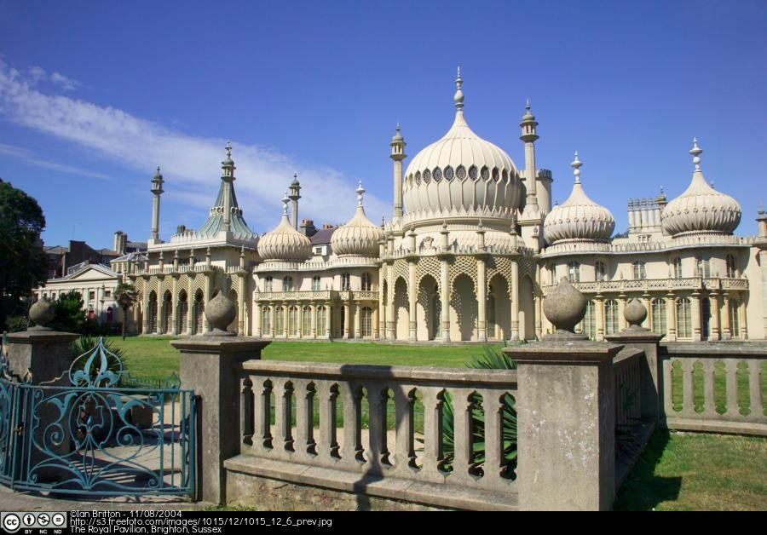

Recommended Reading

These are other online readings (open in a new window) related to this topic.

Blanchard, O. (2012). “And now, something completely different: a word about art” The Brand Builder Blog. Available at: http://thebrandbuilder.wordpress.com/2012/09/17/and-now-something-completely-different-a-word-about-art/

Gompertz, W. (2012). “Which of these artworks is worth £7.9million?” Stylist Magazine, Issue 139. pp.73-74. Available at: http://issue.stylist.co.uk/1B503b66567f69d639.cde/page/1

Semiotics, Part I—Signs, signifiers and signifieds

In this set of four lectures on semiotics you will be introduced to concepts such as ‘sign,’ ‘signifier’ and ‘signified’ and understand their relevance and importance for critical analysis of visual culture, broadly defined. You will also learn about the notion of ‘reality,’ ‘hyperreality’ and ‘simulation’.

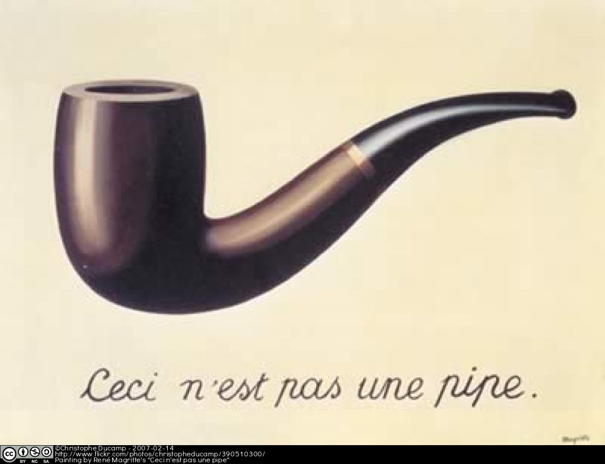

In this first lecture we will reflect on representation and meaning through the process of signification.

Task 2
Reading

Sturken, Marita and Cartwright, Lisa (2001) “Chapter 1: Images, Power, and Politics”. In Practices of looking. An introduction to visual culture; Oxford: Oxford University Press, pp. 10-44.

Read this text and complete the exercises below.

 | Matching1
Title | Key concepts
Text | Match the following concepts with their definitions.
Answer | Representation
Answer | Myth
Answer | Ideology
Answer | Decoding
Answer | Icon
Match | Interpretation of clues to intended, unintended and suggested meanings.
Match | An image with great symbolic meaning that refers to something outside of its individual components.
Match | A process through which we construct the world around us.
Match | The hidden set of cultural rules and conventions through which meanings are made to seem universals.
Match | A system of belief that exists within a culture.
Feedback | Representation: A process through which we construct the world around us.  Myth: The hidden set of cultural rules and conventions through which meanings are made to seem universals.  Ideology: A system of belief that exists within a culture.  Decoding: Interpretation of clues to intended, unintended and suggested meanings.  Icon: An image with great symbolic meaning that refers to something outside of its individual components.

 | Textentry1
Title | Image analysis
Text | Click on the link to see an ad by the clothing company Benetton, and explain in writing what it represents, how it represents it, and what its symbolic meaning may be.  http://lifeincmyk.files.wordpress.com/2011/05/ad-benetton-racism-white-black-yellow-hearts.jpg?w=640&h=442 (opens in a new window)
Feedback | This image shows three human hearts labeled by the race of the person they belonged to. In terms of its denotative (literal, descriptive) meaning, it represents and verbally describes three people from different races. The choice of this organ, as opposed to showing the full bodies of these people, is very significative because hearts symbolize love and life. Looking at them together we get a powerful message about all being equal. Its connotative (cultural and historical) meaning suggests that societies continue being racist. It sends an antiracist message that challenges social attitudes.

 | Textentry1
Title | Values
Text | According to the text, what types of values do we attach to images?
Feedback | The text mentions social, cultural, historical, economic and political values. But also the value of an image to provide information and make events accessible to large audiences as well as an artistic value that provides uniqueness.

Wall

Now find one ad from the web that you want to examine through semiotic analysis and post it on this wall. Make a note on your post about the types of values you would attach to it.

Semiotics, Part II— Simulations and simulacra

This week we will explore the relationships between society, reality and signs. In particular you will learn about the concept of the simulation, simulacra and hyperreal as outlined by the French intellectual Jean Baudrillard.

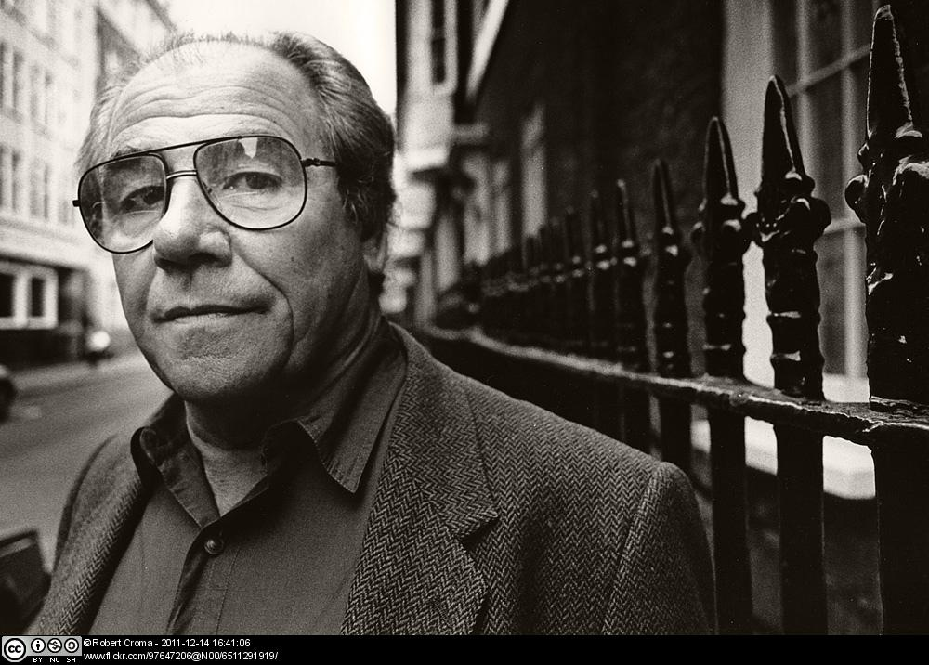

Task 3
Analysis

 | Textentry1
Title
Text | Before reading, go to Google maps (opens in a new window) and follow the instructions below:  - Search for Guildford (United Kingdom).  - Zoom into the center of the town and compare a Map, Satellite view and Street view of Guildford.  - Write an explanation of what you think is real and what would be a simulation of reality.
Feedback | One can argue that none of these representations are indeed real. They are simulations of the real terrain that is being mapped.

Reading

Baudrillard, Jean (1994), Simulacra and Simulation, (opens in a new window) Ann Arbor: The University of Michigan Press.

Read section I. “The Precession of Simulacras” in Baudrillard’s text and answer the question below.

 | Textentry1
Title
Text | In this section Baudrillard provides an example of a fictional story by the writer Jorge Luis Borges that refers to the construction of a real life size map. According to Baudrillard what would be considered such an object?
Feedback | For Baudrillard such a map would constitute a simulation of the real territory.

 | Textentry1
Title
Text | According to Baudrillard what is the difference between the real and the hyperreal?
Feedback | The hyperreal is a real without origin or reality. The real, per Baudrillard, no longer “really” exists because everything is simulation.

Recommended Reading

These are other readings (open in a new window) related to this topic.

Auslander P. (2008). “Jean Baudrillard” Theory for Performance Studies: A Student’s Guide. London & New York: Routledge. pp.56-59

Oberly, N. (2003). “Reality, hyperreality” in Theories of Media, The University of Chicago. Available at: http://csmt.uchicago.edu/glossary2004/realityhyperreality.htm

Sandoz, N. (2003). “Simulation, simulacrum” in Theories of Media, The University of Chicago. Available at: http://csmt.uchicago.edu/glossary2004/simulationsimulacrum.htm

Semiotics, Part III—The gaze, the nude and women’s bodies

This week we will focus on the aesthetics of the gaze, the nude and women’s bodies.

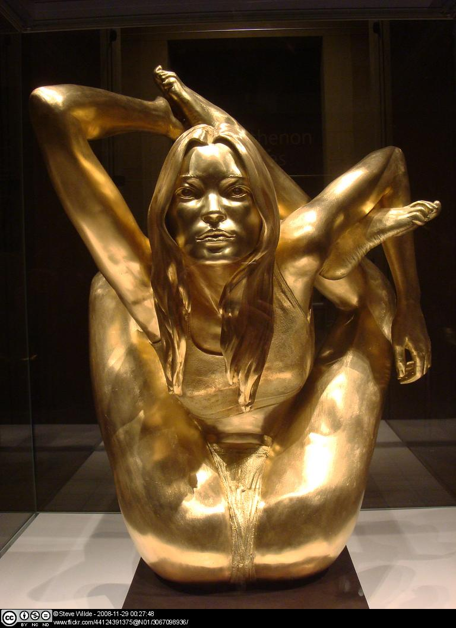

Task 4
Reading

Berger, John (1972). Chapter 3. In Ways of Seeing. London: BBC Books and Penguin Books, pp. 45-64.

First of all, read Berger’s chapter and do the following exercises.

 | Textentry1
Title | Social roles
Text | In this chapter, Berger comments on the social presence of men and women and states that: “The surveyor of woman in herself is male: the surveyed female. Thus she turns herself into an object – and most particularly an object of vision: a sight.” (p. 47) Later on he adds that in the European tradition painters and spectators have been usually men and women have been their objects of contemplation, and that “This so unequal relationship is so deeply embedded in our culture that it still structures the consciousness of many women” (p. 63).  To what extent do you agree or disagree with these statements? Is his description accurate with respect to our current society? Is this only the case for women nowadays?
Feedback | These are open questions. In your response you might state something to the effect that now, every body has potential to be objectified (think of David Beckham pants adverts), but historically and even currently, women still are problematically objectified. You could also comment on whether Berger’s statement on objectification by the opposite sex is necessarily so or whether men and women are in fact surveyed by any person regardless of gender issues.

 | Textentry1
Title | The nude
Text | Berger also examines the nude in western art as a favourite subject focusing on women, and how this tradition was continued by photography.  Make a note on the differences he draws between nakedness and nudity and their connections with art.
Feedback | Nakedness: to be naked is to be oneself.  Nudity: to be nude is to have your nakedness perceived.

Wall

But not only women have appeared naked in the history of art. Now find on the web one example of a nude male body as represented in any art form and post it on this wall. Make a note on your post about the work, its author and what you think it stands for.

Viewing
Now watch episode 2: “Women in Art” (30:54 min) (opens in a new window) of the Ways of Seeing documentary and complete the exercises below.

 | Textentry1
Title | Women on representation of women
Text | In the last part of this episode (from 16:23), Berger gathers five women to discuss the content of the programme. What are these women reactions to how women are represented in art?
Feedback | These women criticise the paintings for:  - not showing real women,  - idealising their bodies,  - exaggerating their sexual attributes,  - lacking in dynamism,  - humiliating women presenting them without clothes  - being nude is not equivalent to being free.  This is presented by them as opposed to photographs which they see as real and possible.

 | Textentry1
Title | Narcissism
Text | How is narcissism defined in the discussion? Do you agree with the differences highlighted between narcissist attitudes in men and women?
Feedback | Narcissism is defined as self-delight. The second question is open. You might think that men and women have different narcissist attitudes or that their attitudes are very similar. Justify your opinion.

 | Textentry1
Title | Real bodies versus bodies in art
Text | What is identified at the end of the discussion as the painful part of being aware of your own female body compared to the bodies represented in art? Is this still the case nowadays? In what other contexts would this apply?
Feedback | The painful part is the feeling of inadequacy, trying to measure up to these constructions of erotic women. Dance and Film establish idealized bodies and body types which set up these false expectations in society. Celebrity culture, celebrity gossip magazines, fashion magazines, adverts all circulate false images of women’s bodies. Perfection sells.

 | Textentry1
Title | More real representations in art
Text | This female character in an Italian fresco from 1338 is identified in the discussion as more representative of women as people rather than simply passive bodies.  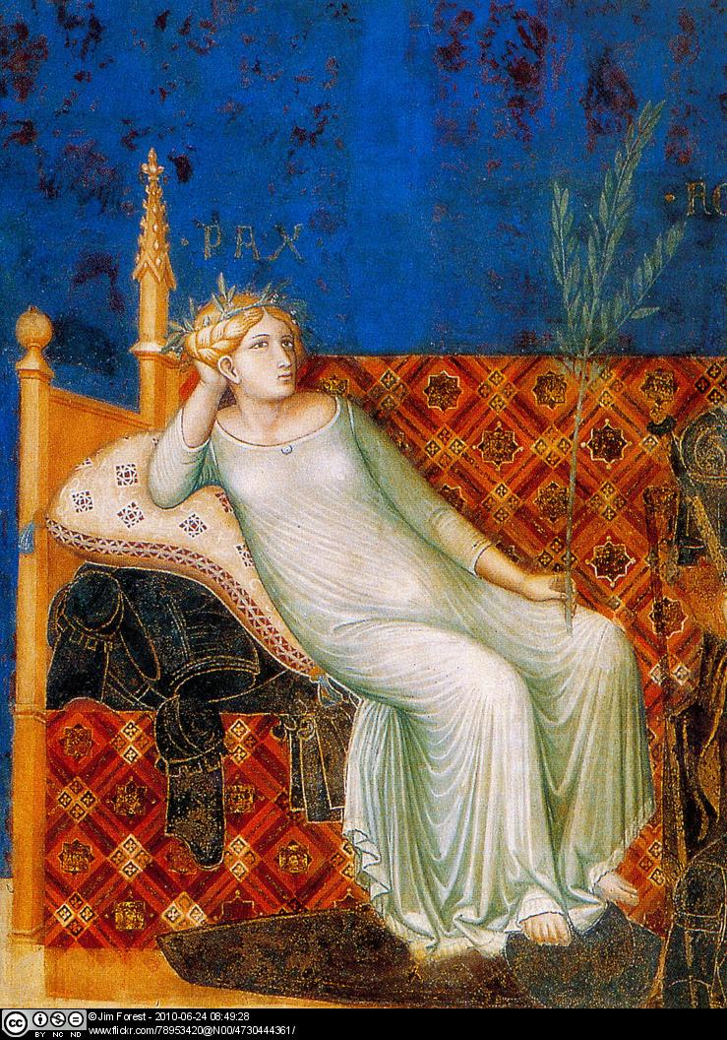  Do you agree with the explanation provided in the programme about what this woman represents? Do you know of any other artistic representations of women in dance or film that present them in a similar way?
Feedback | These are open questions.

Recommended Reading

This is another online reading related to this topic.

Kimmelman, M. (2009). “At Louvre, Many Stop to Snap but Few Stay to Focus.” New York Times. 2 August. Available at: http://www.nytimes.com/2009/08/03/arts/design/03abroad.html (opens in a new window)

Semiotics, Part IV—Images, modernism and postmodernism

This week we will study the concept of ‘modernity’ and explore its connections with the concepts of spectatorship and gaze (the act of looking), in particular as presented by the French philosopher Michael Foucault.

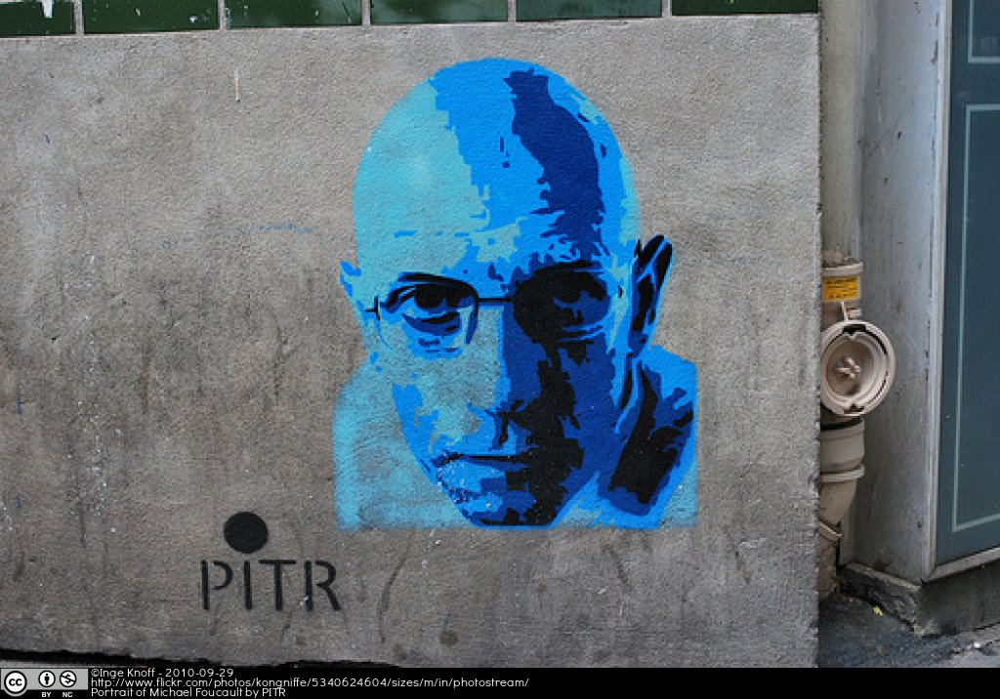

Task 5
Reading

Sturken, Marita and Cartwright, Lisa (2001) Chapter 3: “Spectatorship Power and Knowledge”. In Practices of looking. An introduction to visual culture; Oxford: Oxford University Press, pp. 93-139.

Read this text and answer the question below.

 | Textentry1
Title | Theories of the gaze and spectatorship
Text | According to the text, the theories of the gaze and spectatorships are theories of address rather than of reception, theories that help us consider the ways that an image invites certain responses from specific viewers. What aspects of the looking practices should we consider?
Feedback | - the roles of the unconscious and desire.  - the role of looking in the formation of the human subject as such.  - the ways that looking is always a relational activity and not simply a mental activity.

Viewing

Gilda (1946) is a black and white movie of the film noir genre. Film noir is a Hollywood film category that focuses on a crime and usually features a femme fatale, a sexy yet dangerous woman.

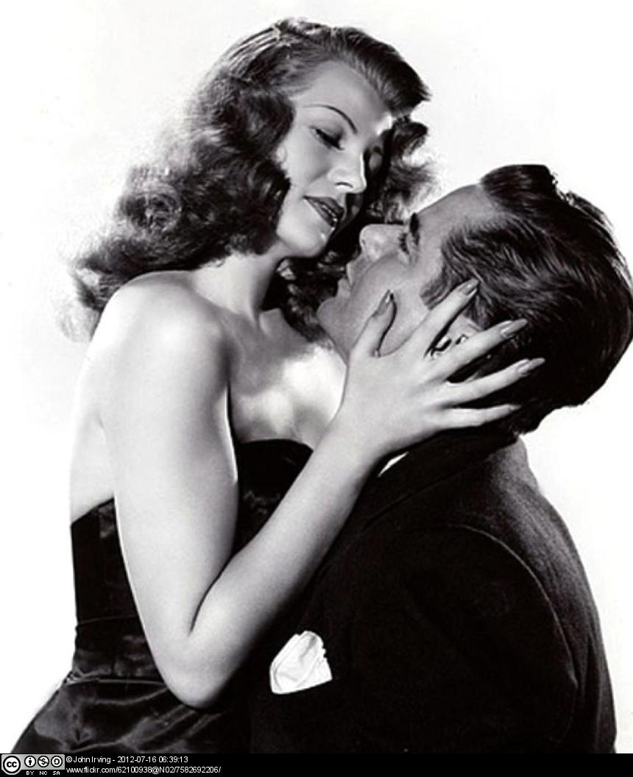

In this film, Rita Hayworth plays the character Gilda and in a famous “striptease” scene she both sings and dances to the shock, amusement and anger of the various characters in the film. The camera plays an important part in constructing the scene. Watch the Gilda clip (03:43 min) (opens in a new window) and think about how the camera objectifies Gilda.

Reading

Sturken, Marita and Cartwright, Lisa (2001) Chapter 7: “Postmodernism and Popular Culture”. In Practices of looking. An introduction to visual culture; Oxford: Oxford University Press, pp. 237-277.

Read this text and answer the questions below.

 | Textentry1
Title | Postmodernism
Text | How do Sturken and Cartwright define postmodernism? How is postmodernism different from modernism?
Feedback | Postmodernism is a cultural, historical and ideological moment where the concepts of universalism, truth and presence are questioned. Whereas modernism focused on the individual as whole and complete, a unified and universal truth, and metanarratives (grand narratives) postmodernism advocates a fragmentation and deconstruction of ideas, identities and metanarratives.

Capitalism, Marxism and art, oh my! Part I—Moving with Marx

In this set of two sessions on capitalism and Marxism you will be introduced to concepts such as ‘surplus value,’ ‘capital and ‘mode of production’ and study their relevance and importance for critical analysis of visual cultural production (film, dance, art, etc).

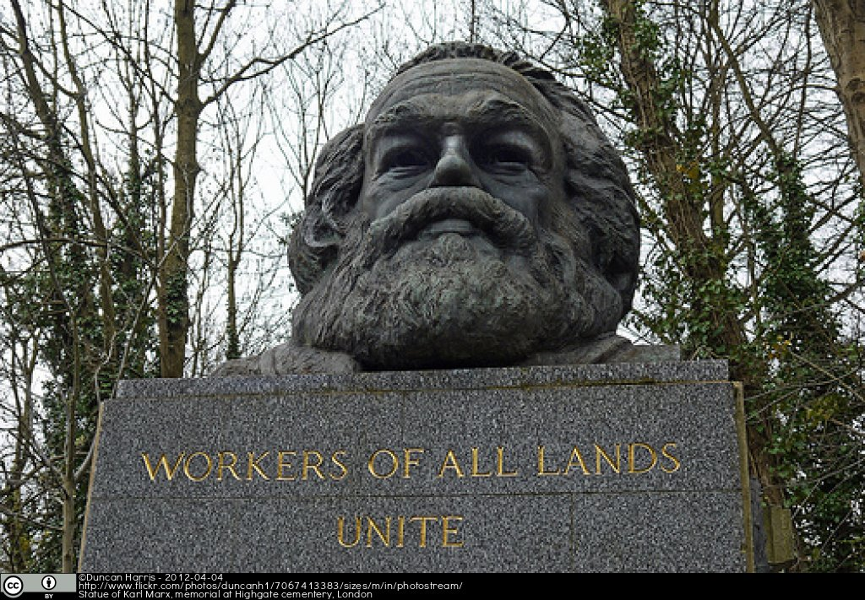

This week we will examine concepts stemming from Marxist cultural analysis which include: surplus value, capital and means of production among others. We will study their relevance and importance for critical analysis of culture and cultural production (film, dance, art).

Task 6
Reading

Woodfin, R., Zarate, O. and Appignanesi, R. (2004) Introducing Marxism. Cambridge: Totem Books.

Read pages 12-13, 30-69 of this text and complete the exercises below.

 | Matching1
Title | Marxist terminology
Text | Match the following terms with their definitions according to Marx.
Answer | Mode of production
Answer | Surplus value
Answer | Exchange value
Answer | Use value
Answer | Capital
Answer | Commodity
Match | Monetary value that gets attached to a commodity
Match | The tools and equipment that produce the commodity
Match | Money, value
Match | Excess value of a commodity
Match | Practical function of the commodity; what it does
Match | An object or thing which satisfies human needs
Feedback | It is important to understand how these terms function in cultural production.  Mode of production: The tools and equipment that produce the commodity  Surplus value: Excess value of a commodity  Exchange value: Monetary value that gets attached to a commodity  Use value: Practical function of the commodity; what it does  Capital: Money, value  Commodity: An object or thing which satisfies human needs

Viewing

Watch this extract of Disney’s 1940 movie The Sorcerer’s Apprentice (09:44) (opens in a new window) and complete the exercises below.

 | Matching1
Title | Identifying factors of the production process
Text | Match the factors in the production process with specific characters or objects in the film.
Answer | Labourer
Answer | Commodity
Answer | Owner of the means of production
Match | The Sorcerer
Match | Mickey
Match | The Sorcerer’s hat
Feedback | Labourer: Mickey (although he tries to make the broom the laborer)  Commodity: The Sorcerer’s hat  Owner of the means of production: The Sorcerer  If you still have trouble understanding the function of laborer, commodity, means of production think back to the content of the lecture and my analogy with your marks and University.

Analysis

 | Textentry1
Title | Practices and modes of production
Text | Think about dance and film making practices and modes of production and take notes to complete this table.  Factors Dance Film  Factory  Labourers  Modes of production  Surplus value  Blank table to take notes on dance and film making practices and modes of production
Feedback | Your notes could be something like these.  Factors Dance Film  Factory dance school film studio  Labourers dancers, choreographers, teachers crew, actors, directors  Modes of production rehearsals, performances shooting, film distribution/marketing  Surplus value virtuosity, technical skill celebrity capital, profit of film, branding, popular cultural references, cultural capital  Example notes on dance and film making practices and modes of production.

Capitalism, Marxism and art, oh my! Part II—Branding

This week we will consider branding and consumerism in a capitalist culture.

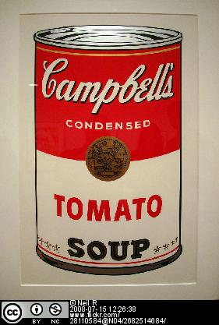

Task 7
Reading
Sturken, Marita and Cartwright, Lisa (2001) Chapter 6: “Consumer Culture and the Manufacture of Desire”. In Practices of looking. An introduction to visual culture; Oxford: Oxford University Press, pp. 189-236.

Read this text and answer the questions below.

 | Textentry1
Title
Text | Can you think of a product that you (past or present) were obsessed with? How was it branded? What type of desire did it produce in you?
Feedback | This is an open answer.

 | Textentry1
Title
Text | How can you explain your experience as a consumer through the analysis Sturken and Cartwright provide?
Feedback | This is an open answer.

 | Textentry1
Title
Text | How might you make a short film or a short piece of choreography about it?
Feedback | This is an open answer.

Viewing

Now watch Logorama (16:01) (opens in a new window) a French animation from the collective H5, François Alaux, Hervé de Crécy and Ludovic Houplain, 2009 and answer the following question.
 | Textentry1
Title | Brands
Text | What brands did you recognize in Logorama?
Feedback | You might have identified these brands:  - Malibu (rum)  - Pringles (crisps)  - Lego (toys)  - Pizza Hut (pizza restaurant)  - Esso (petrol)  - Fanta (drink)  - McDonalds (fast food)  - MasterCard (credit card)  And many other logos and references to famous companies in the USA.

Reflection

Now you are going to think about branding in art.

 | Textentry1
Title | Artists brands
Text | Designing a personal brand means thinking about how you want to be perceived by others.  How might a dancer, choreographer, filmmaker brand himself or herself? What effect might branding have on the work of an artist?
Feedback | This is an open answer.  You could have written down, for instance, that it is important for a choreographer to formulate a clear and interesting vision of their work, think of a suitable name and logo for their company, make frequent press statements and prepare any other communication packages to reach potential funders and audiences. Similarly, you could have also made a note about a film director that works closely with a designer to invent a brand identity of their film production.  Branding your professional persona includes nowadays using social media and websites to promote your work. This is quite important as it has an immediate global reach. Artists need to decide what they want the target audience to be, and in what style they are going to talk to this audience.

Wall

Find an example of an artist who you think utilizes the capitalist marketplace well and post one of his or her works on this wall. Make a note on your post about the work and its author. Be prepared to discuss and qualify your example.

Bodies and protest, Part I

This next set of two lectures examines how art making practices engage with social commentary and/or protest. From murals, to gatherings, to flash mobs, to sit ins, die-ins, to free-running, to styles of dancing as protest (such as krump or clowning). We will think about how bodies protest, what they protest against and the methods through which these protests occur.

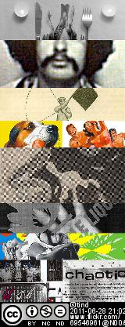

This week we will focus on protest through the body.

Task 8
Reading

Foster, Susan (2003). “Choreographies of Protest” Theatre Journal 55, pp. 395-412.

Read this text and answer the questions below.

 | Textentry1
Title | Three moments in history
Text | What are the three moments in history that Foster addresses in her text?
Feedback | - The lunch counter sit-ins in the 1960s USA.  - The ACT UP die-ins in the 1980s in response to the AIDS epidemic.  - The 1999 WTO Protests in Seattle, Washington USA.

 | Textentry1
Title | Protesting bodies
Text | For each of the three moments, what were the bodies doing as acts of protest?
Feedback | They were sitting quietly (at the lunch counters); They were “dying” (on streets and in buildings); They were taking over.

 | Textentry1
Title | The agency of the body
Text | Why is the body an important agent protest according to Foster?  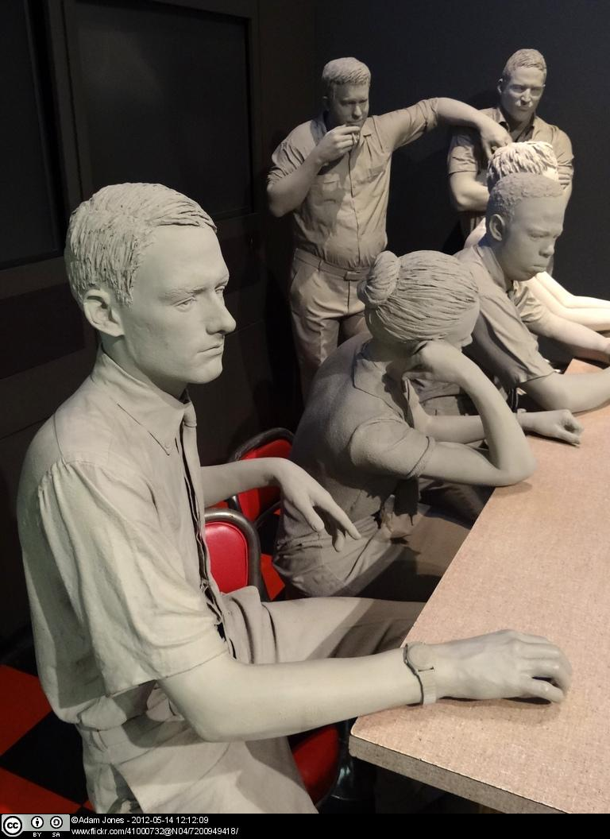
Feedback | She states that the body has a central role in “enabling human beings to work together to create social betterment” (p. 397).

Forum

Go to the discussion forum “Protest” and discuss the following questions before your lesson.
- Why do you think it is important to protest?
- What has been a recent worldwide protest? Explain the motives and the people involved.

Wall

Find on the internet an example of a dance piece or film or documentary that is about protest or features protesting and post one of his or her works on this wall. Make a note on your post about the work and its author. Be prepared to discuss and qualify your example.

Recommended Viewing

These are online documentaries (open in a new window) related to this topic.

Eyes on the Prize, Episode 3, “Aint Scared of Your Jails 1960-1961”(55:03). Available at: http://www.youtube.com/watch?v=NJF9Z9diegA

This Is What Democracy Looks Like (Seattle 1999 WTO). Documentary by Jill Freidberg and Rick Rowley (01:08:51). Available at:

http://www.youtube.com/watch?v=yBUZH2vCD_k

Bodies and protest, Part II

This week we will look at street art, parkour and the relationship between art and society as manifested on the everyday streets.

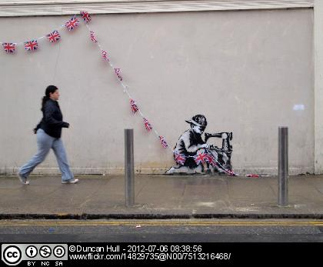

“I painted this on the side of Poundland in North London. A shop which sells cheap jubilee merchandise, is located on the route of the Olympic torch relay and was caught using sweatshop labour two years ago. But I only discovered any of this afterwards - I just thought it was a nice coloured wall.” (Banksy, 2012)

Task 9
Reading

Read this article and answer the following questions.

Ortuzar, J (2009). "Parkour or l’art du déplacement: A Kinetic Urban Utopia". TDR: The Drama Review, Volume 53, Number 3, Fall 2009, pp.54-66.

 | Textentry1
Title
Text | What impact do bodies have on city spaces?
Feedback | They can inscribe their subjectivity onto it and create tactical forms of shifts and changes.

 | Textentry1
Title
Text | How is the city an example of ideology and capitalism?
Feedback | The structures of the city and the capital invested in the order and structure exemplify late capitalist ideology.

 | Textentry1
Title
Text | What do street art and parkour do to question the capitalist ideological structures of the city?
Feedback | They comment on the constructed nature of these restrictions and insert commentary through the body or the graffiti onto these structures.

Viewing

Watch the excerpt from the 2010 documentary Exit Through the Gift Shop (05:15 mins) (opens in a new window) by the street artist Banksy and answer the following questions.

 | Textentry1
Title
Text | How does the beginning of the documentary present the director?
Feedback | He is presented as a curious fan, adventurous and a “real filmmaker’.

 | Textentry1
Title
Text | Why do you think they maintain the anonymity of the street artists?
Feedback | One way to look at it is that this may add to the mystique of the artist, the practice and it also prevents them from possible arrest for damaging public property.

 | Textentry1
Title
Text | What is street art?
Feedback | Street art is a form of art that uses graffiti, tagging, postering (to name a few) to decorate city walls, buildings. It started as a subcultural art form but has been commodified considerably (as you will see by the rise and commercial success of Mr Brainwash in the Banksy film).

 | Textentry1
Title
Text | How does street art function as a type of protest? What is it protesting?
Feedback | Street art functions as a type of protest because it comments on the way the city can be used as a canvas. The city and its buildings and wall act as background to the art which often makes fun or engages in an ironic distancing from the role capitalism plays in shaping our realities. Street art also protests the commercialization or commodification of art. For example, Bansky states that he never makes his art for the money. It has never been about that and he raises concerns about the success of Mr Brainwash in the documentary.

Wall

Search the internet for information on the street artist Banksy and take a look at his work. Choose one of his works and post it on this wall. Make a note on what commentary the piece might be making. Be prepared to discuss and qualify in class the work you chose.

The arts during times of crisis

This week we will be examining the role of art in a time of crisis.

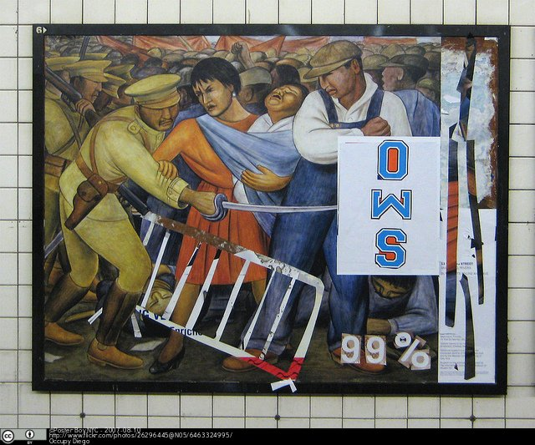

Task 10

Reading

Schmidt Campbell, M (2006). “The Role of the Arts in a Time of Crisis” Artistic Citizenship: A Public Voice for the Arts. Eds. Mary Schmidt Campbell and Randy Martin. New York: Routledge, pp. 23-32.

Read this text and answer the question below.

 | Textentry1
Title | Defining crisis
Text | According to the author, what exactly is a time of crisis?
Feedback | The authors speak about the ongoing cultural wars in the United States and the role that artists have in addressing this crisis through their work.

Reflection

Now think of responses to the following questions.

 | Textentry1
Title | Current crises
Text | Although written from a US perspective and right after the attack on the World Trade Center, without a doubt we are still in a time of crisis in 2012. What are some of the crises that current UK (and world) citizens face?
Feedback | Some examples of current crises are:  - Austerity cuts and their impact on the arts.  - Rise in fees for education.  - Lack of varied employment opportunities.  - Continued disenfranchisement of the working class.  - Environmental catastrophe.  - Global debt.  - Overpopulation.  - Sustainability of resources.  - Clean water.  - Racism, Sexism, Homophobia.  You might have thought of others.

 | Textentry1
Title | The function of art
Text | In your view, what can the arts do during a time of crisis?
Feedback | This is an open response but you might say something about how art allows for conversations and commentaries to occur about the state of the world. It is through the creation of discourse about a specific issue and its representation in the arts, that art can effect change.

Viewing

Watch the TED Talk Can art change the world? (24:09 mins) (opens in a new window) from 2011 by JR to see an example of how some artists are trying to change the world.

Forum

Find on the internet a newspaper or magazine article about a specific global problem. Go to the discussion forum “Problems and artistic solutions” and post a link to the article and your answers to the following questions. Comment on at least one post from another student.
- What did you learn from this article that you did not know before?
- What can you do to help? Like JR’s idea, can you come up with something that can help draw attention to the problem and an artistic way of drawing the attention?

Wrap Up Session

Before coming to the session read again the description of the module and think about whether you have achieved the proposed learning aims and outcomes.

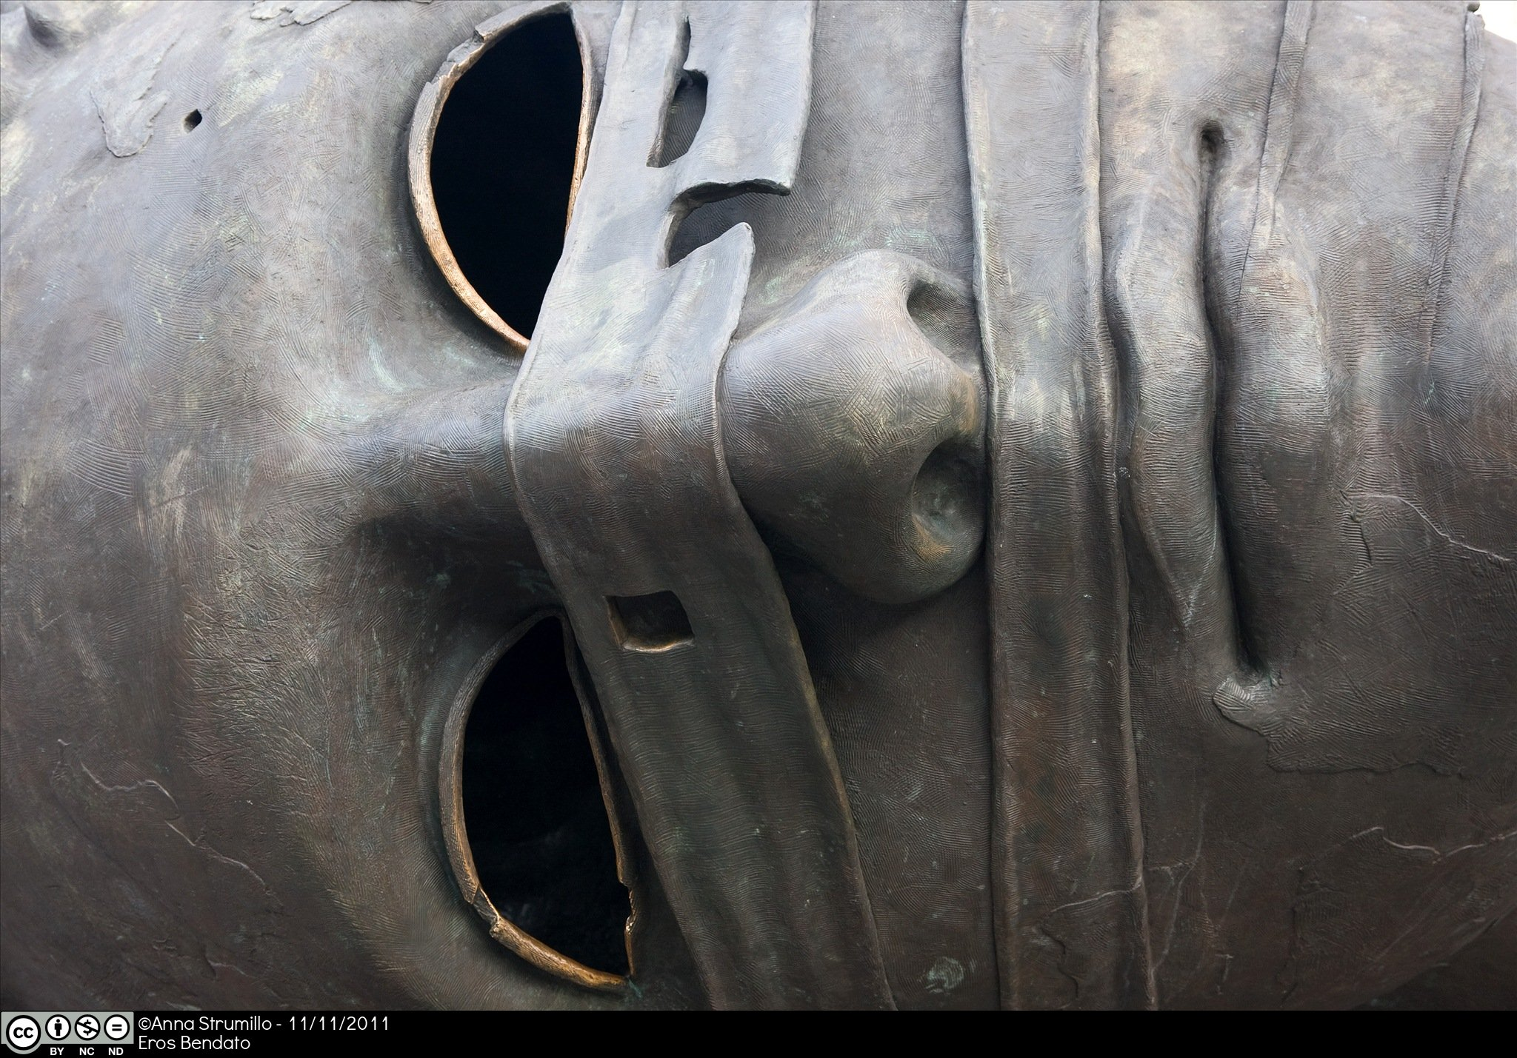

This week during our class we will work on the following:

- We will discuss the possibility of making socially informed art in a world that discourages critical, independent thought.
- You will work in groups were you will have to negotiate and propose creative strategies that could galvanize your generation to think about how you want to help change the world through the arts.

Acknowledgements

Authors
Tasks by Inma Álvarez and Melissa Blanco Borelli, University of Surrey.

Critical reading by Jane Chan and Sophie Klepacz.

Technical support by Rachel O’Callaghan, University of Surrey.

Images
All images in this learning package are Creative Commons. This is a full list with detailed references (with links where applicable opening in a new window).

Introduction
The Globe of Information by Manolis Moumouzias, Greece, 9 April 2012, available at: http://www.flickr.com/photos/26915339@N04/7060438199/

What is art? What is society?
Planed (2007) by Gilbert and George, digital art. Piece owned by Inma Álvarez.

Portrait de Madame Devauçay (1807) by Jean Auguste Dominique Ingres, oil on canvas, Musée Condé, Chantilly. Image in public domain, available at: http://upload.wikimedia.org/wikipedia/commons/2/2c/Portrait_de_Madame_Devau%C3%A7ay_-_Ingres_-_Mus%C3%A9e_Cond%C3%A9.jpg

The Royal Pavillion, Brighton (2004). Photo by Ian Britton, 11 August 2004, available at: http://www.freefoto.com/preview/1015-12-6/The-Royal-Pavilion--Brighton--Sussex

Semiotics
Ceci n'est pas une pipe (1928-29) by Rene Magritte, oil on canvas, Los Angeles County Museum of Art, Los Angeles, California. Photo by Christophe Ducamp, 14 February 2007, available at: http://www.flickr.com/photos/christopheducamp/390510300/

Benetton ad (2011), available at:
http://lifeincmyk.files.wordpress.com/2011/05/ad-benetton-racism-white-black-yellow-hearts.jpg?w=640&h=442

Portrait of Jean Baudrillard, Soho, London (2011). Photo by Robert Croma, available at: http://www.flickr.com/photos/97647206@N00/6511291919/

Siren (2008) by Marc Quinn, sculpture of Kate Moss in gold, British Museum, London. Photo by Steve Wilde, 29 November 2008, available at: http://www.flickr.com/photos/44124391375@N01/3067098936/

Detail of Allegory of the Good Government (1338) by Ambrogio Lorenzetti, Palazzo del Comune, Siena. Photo by jimforest, 24 June 2010, available at: http://www.flickr.com/photos/78953420@N00/4730444361/

Michael Foucault by PITR, wall painting in Montmartre, Paris. Photo of by Inge Knoff, 9 September 2010, available at:
http://www.flickr.com/photos/kongniffe/5340624604/in/set-72157594257446673

Gilda (1946), Rita Hayworth and Glenn Ford, movie. Photo by John Irving, 16 July 2012, available at: http://www.flickr.com/photos/62100938@N02/7582692206/

Capitalism, Marxism and art
Statue of Karl Marx, Highgate cemetery, London. Photo by Duncan Harris, 4 April 2012, available at: http://www.flickr.com/photos/29057345@N04/7067413383/

Tomato (from Campbell's Soup I) (1968) by Andy Warhol, Screenprint 197/250, The Metropolitan Museum of Art, New York. Photo by Neil R., 15 July 2008, available at: http://www.flickr.com/photos/islespunkfan/2682514684/sizes/l/in/photostream/

Bodies and protest
krump & clown (2011) by tind, collage, available at: http://www.flickr.com/photos/tind/5881279283/sizes/l/in/photostream/

Diorama of Lunch Counter Sit-Ins Protest, National Civil Rights Museum, Memphis, Tennessee. Photo by Adam Jones, 14 May 2012, available at: http://www.flickr.com/photos/41000732@N04/7200949418/

Poundland Jubilee Flag maker (2012) by Banksy, mural painting, London. Photo by Duncan Hall, 6 July 2012, available at: http://www.flickr.com/photos/14829735@N00/7513216468/

The arts during times of crisis
Occupy Diego (2007) by Poster Boy NYC, available at: http://www.flickr.com/photos/26296445@N05/6463324995/

Wrap up session
Detail of Eros Bendato (1999) by Igor Mitoraj, Kraków. Photo by Anna Strumillo, 11 November 2011, available at:
http://www.fotopedia.com/items/DZ8DEbT0DZM-skyRjI02W5w

Licence

This resource was released as an Open Educational Resource through the Contexts, Culture and Creativity: Enriching E-Learning in Dance project funded by JISC Strand A: Digitisation & Open Educational Resources.

All the text is licensed under the terms of the Creative Commons Attribution-Non-Commercial--Share Alike 2.0 UK: England & Wales Licence.

Images are licensed under Creative Commons as specified in their individual banner.

The JISC logo is licensed under the terms of the Creative Commons Attribution-Non-Commercial-No Derivative Works 2.0 UK: England & Wales Licence. All reproductions must comply with the terms of that licence.

The University of Surrey logo and the National Resource Centre for Dance logo are owned by the university and should not be produced without the express permission of the university.

