D) Communication

During your PhD candidature you will need the skills to operate within a wide range of communicative situations, from talking to other PGR students, to your supervisor and other academics or researchers at conferences. You will have to give formal presentations, master written communication: such as reports, papers, chapters of your thesis, PowerPoint Presentations, posters for conferences, blogs, twitter feeds, facebook status updates, etc.
Communication therefore links with the intellectual dimension of the PhD, but it also relates to the wider research context, where you communicate your intellectual achievements in different situations/ to different audiences.

Why is this important to the PhD process?
Because your PhD is communicating your ideas, and those ideas need to be pitched perfectly to the audience at hand. You always need to ask yourself ‘who am I communicating with, how, and why?’

See overleaf for exercises.

Part I – Analysis/Evaluation of Visual Communication

You are shown two posters advertising research projects. They are arranged as they would be on a poster display wall at a conference. Focus on your first impressions of these two posters side by side, as you would if you saw them on a display wall. You can view the full-size poster files for details.

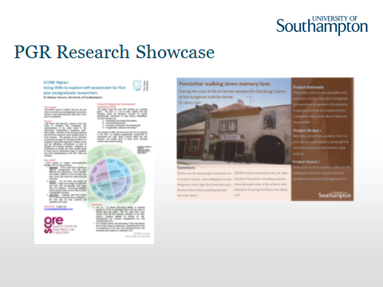

The full-size poster files are available as allied resources on the Blackboard Site.
You can write into this box and expand it as you require.

Task: Compare the two posters with a view to the following aspects:

- List 3 similarities relating to visual aspects:

- List 3 differences relating to visual aspects:

- What is being communicated?

- What context do you think they were designed for?

- Which poster requires more information for interpretation, and what information is this?

See overleaf for self-assessment and next steps.

Self-Assessment Communication Part I

How well have you done on the task?
You can self-assess how well you have done on this task by allocating 2 points to each of these aspects that you picked up correctly. This will give you a mark out of ten, which will be an indicator of your strengths and weaknesses in the area of communication.

- Visual similarities from the list (2 points if you get at least 3, 1 point if you get 1 or 2): use of colour scheme, text framed in columns, use of sub-headings, use of logos;

- Visual differences from the list (2 points if you get at least 3, 1 point if you get 1 or 2): amount of text used, use of images as background or content, use of different logos, portrait or landscape orientation, mentioning of contact details

- What is being communicated (2 points if you get at least 3, 1 point if you get 1 or 2): Subject matter (Score project; German-speakers), research questions (use of OER for 1st-year PGR self-assessment; use of memories in narratives), methodologies (interviews, observation; narrative analysis).

- Context (2 points if you get both posters right, 1 point if you only get 1): Score = stand-alone poster with necessary information and contact details; German-speakers = raising attention during poster session with the researcher present to answer questions

- Which poster requires more information for interpretation, and what information is this? (2 points if you get at least 3, 1 point if you get 1 or 2) History of the project, further information on where the project is headed, process/ analysis, use/ explanation of specific terms or jargon.

Next Steps – Communication Part I

5 Points of Less
If you have assigned yourself less than 5 points, your skills in communication and interpretation need further development. As a first step you should go online and do some more training.

6-8 Points
If you have assigned yourself between 6 and 8 points, you should consider putting an abstract for a poster presentation to a local conference organised by your discipline or subject association. This will give you practice at creating posters and will enable you to gain confidence, receiving feedback from your peers and staff.

9-10 Points
Have you put in a poster before? If so, why not consider sharing your knowledge with other students by running peer study session on Communication and/ or Working with Images or putting your poster on display in your discipline.

