 | Do not manually edit this table.
Title | Ballet
Keywords | Ballet, Somatic approach, Opposition, Alignmnent, Battement tendu, Musicality, Verticality, Metaphors
Description | Ballet online tasks that involve some reading, watching and reflecting on key aspects of ballet practice. Year 2 undergraduates, Higher Education Level 5.
Version | 14012013 1
Status | final
Cost | no
Restrictions | yes
Description | Creative Commons Attribution-NonCommercial-ShareAlike 2.0 Licence.
Author | Inma Álvarez and Jennifer Jackson
Organisation | University of Surrey
Date | 14 January 2013

Introduction to the online tasks

This is a set of ten tasks to help you develop your practical and theoretical knowledge about ballet. These online tasks include selected readings and viewings with questions, reflective activities and other online activities such as discussion forums and mind maps.

Note that the recommended texts are not available online. The activities for each week will take you approximately one hour to complete.

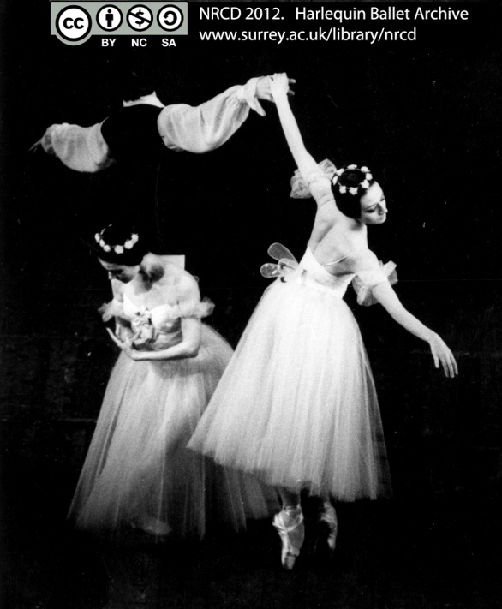

The work you do online will be exploited during your classes and taken into account in assessing your attitude and achievement. You are encouraged to develop your own practice of ballet from a somatic perspective over the course of the module.
Make sure you come ready for your lessons by completing the relevant activities beforehand.

Saving your answers

If you wish to save your answers to the e-learning tasks and keep this information for further use, we suggest that once you have completed your answers on a page and seen the feedback, before you continue, save them in your computer (or in a pen drive) as a pdf by using the "Print to File" option.

To do this, right click on the page you would like to save and choose “Print”.
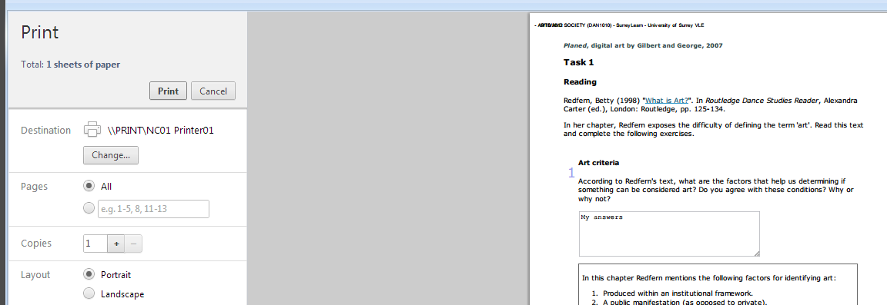

From the options on the left, make sure your Destination is “Save as PDF”.
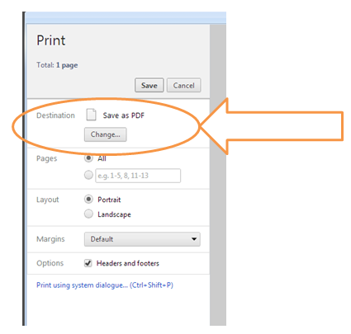

Task overview

Here you can see at a glance a calendar of the online tasks you are expected to complete in this module and how they fit with your classwork. You should aim at completing the online activities before your lesson.

Task | Concepts | Online activities | Classwork
1: Key ballet concepts | Geometry, en place (centre), en dehors, en dedans | 1.1-1.2 | Work on key ballet concepts.
2: Dance training | Truthful, correct, good  Vulnerability | 2.1-2.4  Forum: vulnerability | Discuss key aspects of training.
3: Somatic approach | Somatic experience  Somatic techniques  Dance diagrams | 3.1-3.2  Mind map: somatic techniques | Discuss collaborative mind map on somatic techniques.
4: Visualising the body | Verticality, the line of aplomb, gravity | 4.1-4.2 | Develop an image of the 5th position and use it as a tool for your practical understanding.
5: Moving from the five positions | Opposition, alignment | 5.1-5.3 | Work on the feeling of alignment and opposition.
6: Exploring inside and outside space | Épaulement, tendu, éffacé, croisé, écarté | 6.1-6.4  Mind map: attending to space | Practise the feeling of key concepts.  Examine contributions to collaborative mind map on attending to space.
7: Discussing descriptions and performance | Musicality,  rhythm | 7.1-7.3  Forum: musicality | Create tendu sequence.
8: Understanding a battement tendu | Battement tendu | 8.1-8.4 | Refine tendu sequence.
9: Describing through metaphors |  | 9.1-9.3 | Discuss students’ metaphors for a tendu.
10: Reflecting on your practice |  | 10.1-10.2  Forum: quotes | Integrate understanding as performance.

Ballet: Overview of weekly tasks

Task 1: Key ballet concepts

Learning to dance involves personal engagement with the disciplinary concepts and knowledge of the dance tradition. In this introductory task you will have an opportunity to examine key ballet concepts used in a couple of texts by Roger Tully (2011) and Anna Paskevska (2005).

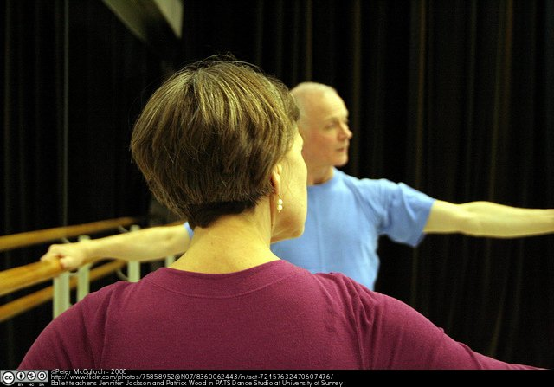

Activity 1.1

First of all, read a few pages (pp. 17 -19) from this text paying attention to key ballet concepts.

Tully, R. (2011) The Song Sings the Bird. A Manual on the Teaching of Classical Dance. Rome: Gremese.

 | Matching1
Title | Ballet concepts
Text | Tully defines the following terms in a particular way. Match these concepts to these descriptions derived from the text.  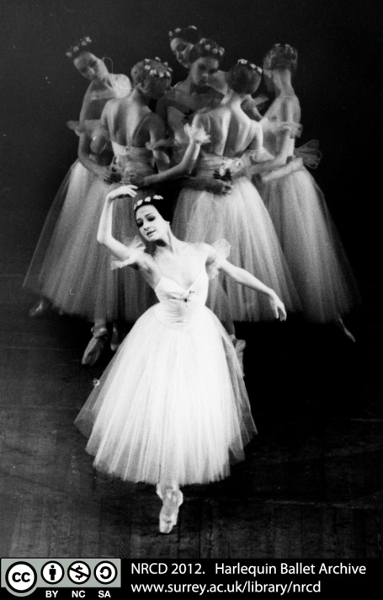
Answer | En place
Answer | Geometry
Answer | En dehors
Answer | En dedans
Match | It is acquired through experience. It helps the dancer understand extension and directions.
Match | The physical direction of a movement inwards, and also an expression of classical dance.
Match | The physical direction of a movement outwards, and also an expression of classical dance.
Match | Being centred, stillness where the connection between the physical, mental and spiritual can be experienced.
Feedback | En place: The centre, stillness where the connection between the physical, mental and spiritual can be experienced.  Geometry: It is acquired through experience. It helps the dancer understand extension and directions.  En dehors: The physical outward direction of a movement and also an expression of classical dance.  En dedans: The physical inward direction of a movement and also an expression of classical dance.  All these are physical actions that have an emotional or expressive dimension that connects with you as a human being. Think about how you understand and would define these terms for yourself.

Activity 1.2

You are going to continue thinking about basic concepts in ballet reading some extracts (pp. 25-27) from a different text.

Paskevska, A. (2005) Ballet Beyond Tradition: The Role of Movement Concepts in Ballet Technique. New York and London: Routledge.

 | Textentry1
Title | The centre
Text | In these pages Paskevska speaks about the centre of the body as a point of control. According to her, where is that point exactly located?  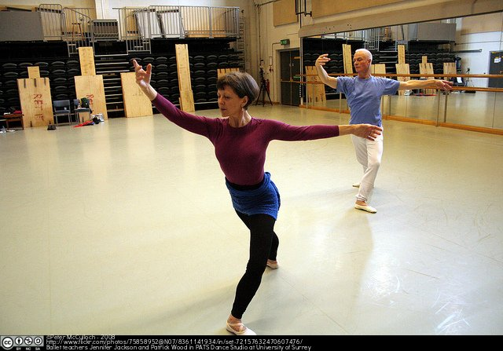
Feedback | For Paskevska the centre can be located in the pelvic area, in the point of crossing between the vertical line of gravity and the horizontal line that divide the erected body in half.  Note that Paskevska also specifies that the location of the centre “depends more on ratio between length of the torso and girth of the pelvis than on gender” and thus “varies depending on the individual physique” (p. 26). Stand upright and try to feel and locate your own centre.

Task 2: Dance training

In this task you are going to focus on crucial aspects of your dance training, including the feeling of vulnerability as a dancer.

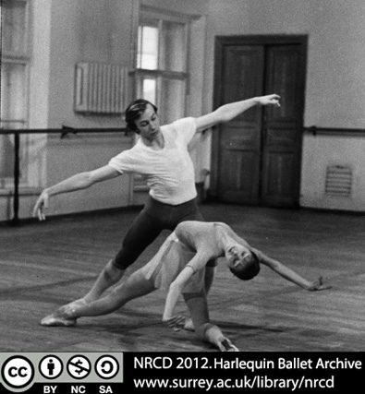

Activity 2.1

In this activity you are going to read a few more pages (pp. 3-7) Paskevska’s book and reflect on what dance training involves.

Paskevska, A. (2005) Ballet Beyond Tradition: The Role of Movement Concepts in Ballet Technique. New York and London: Routledge.

 | Textentry1
Title
Text | In her introduction to her book (pp. 3-7) Paskevska mentions three aspects of dance training. Which are these? Do you agree with this description? Do you think there are additional aspects to training?
Feedback | Paskevska mentions the physics of movement (potential for motion and acquisition of technique), mechanics of movement (acquisition of vocabulary) as well as the aesthetics (shape of gestures).  In your personal response to this question you might have suggested other aspects of training such as musicality, range of dynamics, psychological or emotional dimensions. You might have considered how, for example, in exploring (somatically) the ‘shape of gestures’ you engage creative thinking and emotional expression. Also how ‘acquisition of technique and vocabulary’ in ballet involves timing and a relationship between music and dance.

Activity 2.2

Now read another passage (pp. 15 -16) from Tully’s text and answer the question below about his idea on the dimensions of dancing.

Tully, R. (2011) The Song Sings the Bird. A Manual on the Teaching of Classical Dance. Rome: Gremese.

 | Textentry1
Title
Text | According to Tully, what three worlds need to be united in a dance? Do you agree with his description?
Feedback | For Tully, the physical, spiritual and mental dimensions need to be combined by the dancer in order to be able to connect with his/her audience. The physical forms are shown by his/her moving body, and the mental dimension explores ideas and attitudes. In these pages he does not explain the spiritual plane of the dancer, he simply states that it is not easy “to work directly in the spiritual world” (p. 16). You might agree or disagree with these ideas. What is important is that you form an idea of what dancing is about and that you can explain it in full.

Activity 2.3

In the extracts you have read so far, Paskevska uses the terms ‘good’ (p. 6) and ‘correct’ (p. 7), and Tully uses ‘truthful’ (p. 15) in relation to ballet performance and practice.

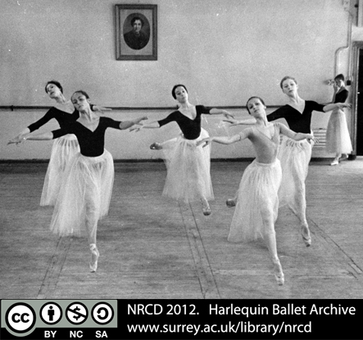

 | Textentry1
Title
Text | What do you understand by each of these terms in this dance context?
Feedback | This is an open response. The following are just a suggestion of how those terms could be understood in the context of ballet.  Good: ‘Good ballet’ accords with the natural laws of the physics of movement. Good practice relates to Tully’s idea of diligence, sustained application and effort in class and in reflection in order to understand the principles through experience. Relating conceptual and practical aspects of practice, to deepen understanding of where the ‘dance’ is and what dance is and how dancing involves spiritual, mental, and physical engagement).  Correct: It means that the dancer applies a ballet technique in an appropriate way, that is “in harmony with the physical laws of motion” (Paskevska, p. 7). Ballet vocabulary is correctly articulated with attention to its fundamental principles.  Truthful: Being attentive to the physical laws, the aesthetic principles in relation to your own experience of your body dancing, for example, recognising the feeling of your weight distributed around the line of the aplomb.  Note however that these terms do not indicate that there is one ‘right’ way of performing or exploring. Ballerina and Director Maina Gielgud commented on the importance to be opened to different approaches: “I worked with so many teachers as a student and it helped me tremendously because I didn’t have this sort of blocked thinking, that there was only one way” (in Newman, 2004, p. 143)

Activity 2.4

As you know, dance training implies a number of challenging experiences. Read this text and contribute to the online discussion forum.

Jackson, J. (2005) My dance and the ideal body: looking at ballet practice from the inside out. Research in Dance Education 6:1-2, pp. 25-40.

In her text, Jackson suggests that the dancer is “open but not vulnerable”. Jackson refers here to the strength that the dancer will derive from diligent practice. The student must be open and engaged in learning and able to trust that her or his vulnerability will not be abused. On the other hand, Tully suggests that “in order for something to happen, the artist must be vulnerable” (Conversation with Jackson, 2012). Teacher and student co-create the ‘climate’ in which the artist can take risks and emotional/personal vulnerability is a part of what enables new connections and discoveries.

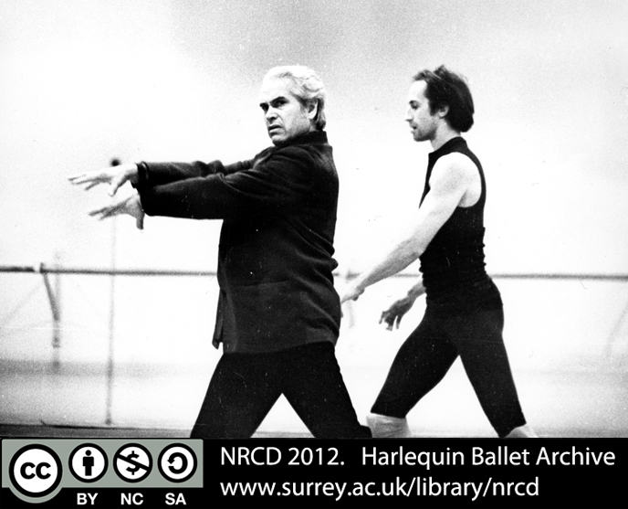

Go to the discussion thread “Dancers’ vulnerability” in the module forum and write your opinions about in what ways you think the dancer is vulnerable, and in what ways you think he/she is not. Discuss with others answers to the following questions: What might vulnerability open up? Is vulnerability necessary? How can it be supported?

Task 3: Somatic approach

This task will help you to start thinking about a practice of dancing that is characterized by reflection on the moving body based on a somatic approach. Here you are going to think of a range of somatic techniques.

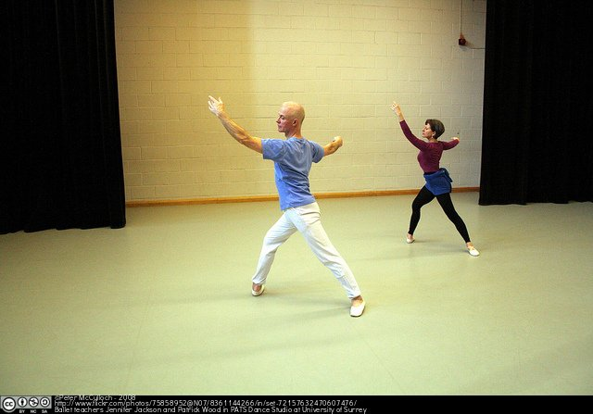

Activity 3.1

Before you start reading, think and respond to this question.

 | Textentry1
Title
Text | What do you understand by a somatic approach?
Feedback | A somatic approach encourages thinking about the body from the first person perspective, that is, my body as I experience it from the inside, rather than my body as an object, observed from the outside.  In the words of Anna Paskevska:  “Many dancers draw on somatic and body/mind techniques in their training. The term “somatics” can be broadly defined as the body perceived from within, that is, a subjective apprehension of the effect of movement on one’s body.” (2005, p. 4)  You will come across further readings and references later on.

Activity 3.2

In the introductory pages to her text Anna Paskevska mentions that:

“There are a plethora of somatic techniques that are available as resources for dancers –including yoga, Pilates, Alexander Technique, Bartenieff Fundamentals, Body Mind CenteringTM, Feldenkrais, and the work of Irene Dowd and Eric Noel Franklin in Ideokinetics” and explains that the basis of her training is the Limón technique “because they deal with quality of motion as contrasted with neuromuscular repatterning, which concentrates on alignment, freedom of the joints, and flexibility.”
(Paskevska, 2005, p. 4)

Are you familiar with any of these techniques? Can you think of any other movement or dance technique that is also somatic? Go to the mind map “Somatic techniques” in the internet and contribute to the map by adding at least one piece of information about a somatic technique. For instance, you can add the name of a different somatic technique, a definition of one of the techniques already on the map, a quote, a relevant image or a link to a video.

Note on using mindmeister

mindmeister is an online mind mapping and brainstorming tool that you will be using in this module. You will receive a message inviting you to contribute to this mind map. For this you will have to sign in with your Surrey email and a password of your choice. In order to access the map from the link provided above you need to right click on the link and choose “Open link in new window”. You will be able to sign in from that window.

To start using this programme, click on “help” icon on the blue bar at the top of the map and then choose “Online help”. Here you can find tutorials on how to edit the map. All you need to do for this activity is in the section “Basics”.

Task 4: Visualising the body

This task deals with the five positions in ballet. In order to explore these positions as shape and movement, it addresses a fundamental principle: Verticality, the line of the aplomb, and the dynamic inherent in the ballet dancer’s relationship with gravity.

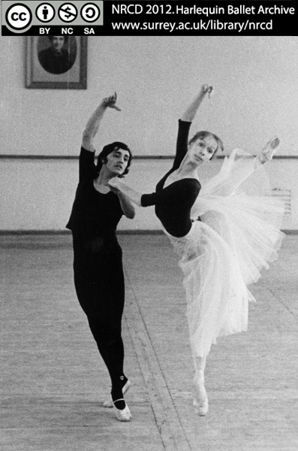

Activity 4.1

You have read Paskevska’s and Tully’s texts for the previous activities and might have noticed that they both use a diagram to visually explain their understanding of dance.

 | Textentry1
Title
Text | What are the similarities and differences between the diagrams in the books (Paskevska, 2005, p. 27; Tully, 2011, p. 17) and this one by Leonardo da Vinci?  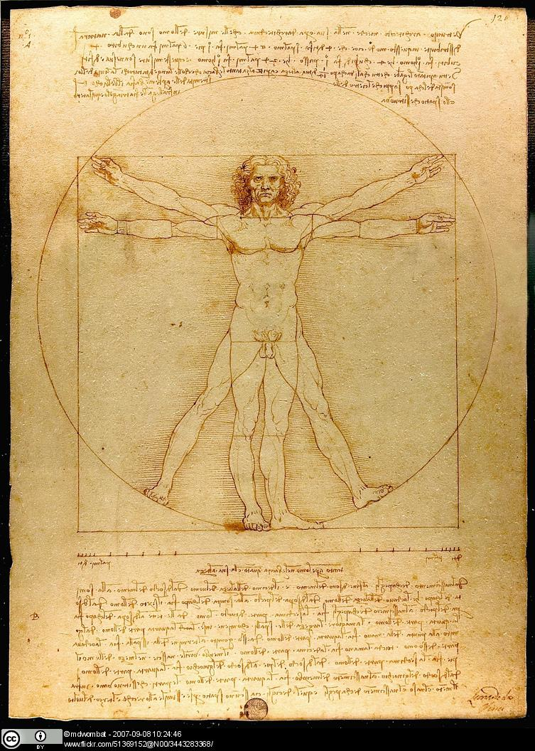
Feedback | Tully is more abstract in his representation. He references both the geometric lines of movement in space and indicates the connection between different worlds (spiritual, mental, physical). His is an ‘open’ image that can be explored in a number of ways.  Paskevska’s circles are around and within the body referring to movement or feeling as experienced in the body. Both circular drawings can be related to the way Leonardo framed the human body in his famous work which refers to the ideal proportions of a human body. He connected science and art.  In turn, Leonardo was inspired by an ancient Roman architect called Vitruvius for whom the human figure provided the proportions for his architecture.  In one of your classes you will have a chance to create your own image about dance as you perceive it.

Activity 4.2

The following questions will help you to think about the verticality of the body facilitated by the spinal column and its importance for ballet technique. Read sections “The Spinal Column” and “Getting Centered” (pp. 17-20) in Valerie Grieg’s text and answer the following questions.

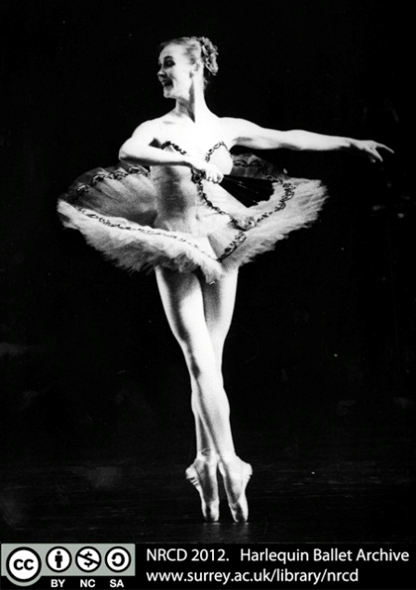

Grieg, V. (1994) Inside Ballet Technique: Separating Anatomical Fact from Fiction in the Ballet Class. London: Dance Books.

 | Textentry1
Title | Lengthening of the spine
Text | What is the main function of the spine? What functions does the lengthening of the spine have in our daily movement and in ballet?
Feedback | The spine (with the help of the pelvis) is key for supporting the weight of the head, rib cage and shoulder girdle.  The lengthening of the spine has anatomical, mechanical, structural and aesthetic functions. It helps protect the vulnerable natural curves of the spine; allows each section of the spine to occupy the space it needs to facilitate breath and greater movement range; lengthens the waist; etc.

 | Textentry1
Title | Images for the 5th position
Text | The 5th position in ballet requires the lengthening of the spine and an awareness of a dynamic of opposition. What images, imaginary lines, metaphors or ideas help you to focus on when using this position?
Feedback | This is an open answer. Your ideas about this position are personal and valid as long as they help you feeling and understanding it. You will talk about them in class.

Task 5: Moving from the five positions

You have already reflected on the feeling of the ballet positions and now you will be thinking about how sustaining and moving from the five positions facilitates physical and aesthetic dimensions of practice.

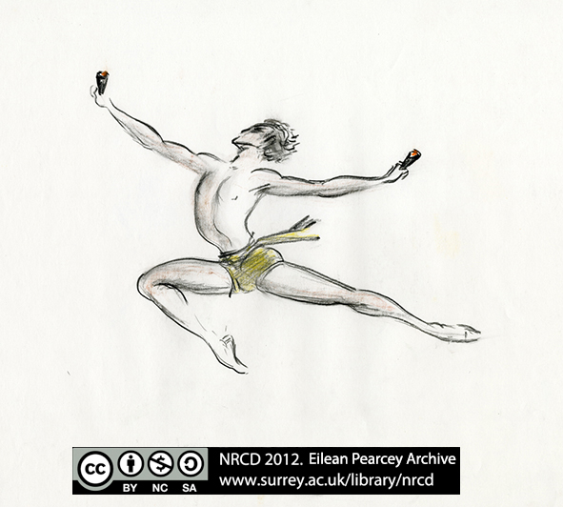

In class we will explore how you move between positions in space and the feeling in the body of opposition and alignment.

Activity 5.1

Tully explains in his book how alignment and opposition are simultaneously engaged. Read a few pages (pp. 9-12 and pp. 32-33) from his book and answer the question below.

Tully, R. (2011) The Song Sings the Bird. A Manual on the Teaching of Classical Dance. Rome: Gremese.

 | Textentry1
Title
Text | According to Tully, what action is enabled by establishing the line of leg from hip joint to the foot?  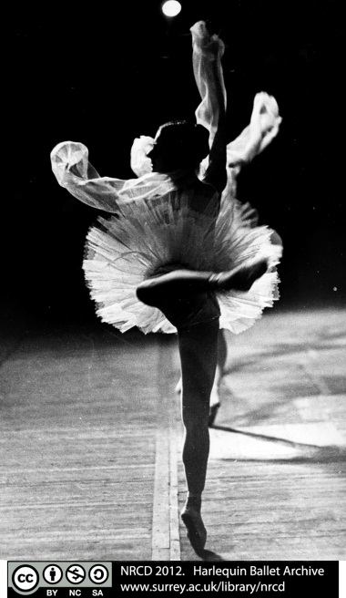
Feedback | The ‘downward thrust’ through the heels and feet, giving the upward lift through the hip joint in the opposite direction (pp. 32-33). You can experience this dynamic when you sustain the 5th position.  Previously (pp. 9 -12) he explains that the passing of the two legs equally across the vertical in the fifth position creates the potential for movement in all directions (front, side and back). This is the ‘spring’ action that not only sustains shape but also enables movement upwards into the air.

Activity 5.2

Paskevska refers to an oppositional pull in ballet technique. Read chapters on “Alignment” (pp. 33-35) and “Opposition” (p. 55-62) from her book and answer the question below.

Paskevska, A. (2005) Ballet Beyond Tradition: The Role of Movement Concepts in Ballet Technique. New York and London: Routledge.

 | Textentry1
Title
Text | What functions of the oppositional pull in ballet does Paskevska mention in her text?
Feedback | She suggests that oppositional pull:  - equalises the forces acting on the body;  - transmits energy in opposite directions from the centre;  - has an important aesthetic function;  - helps to achieve balance.  Paskevska links opposition with achieving balance, while Tully refers to the dynamic of opposition held in a position. In both approaches, the centre is implicit and found in relation to the oppositional pull in the body shape. Both authors express a similar idea: Awareness of the oppositional pull between points in the body that enables freedom of movement.  This image illustrates the downward thrust in the 5th position that supports the reach of the upper body and port the bras into space.

Activity 5.3

In this activity you are going to consider the execution of alignment and opposition in two ballet dancers.

 | Textentry1
Title
Text | These two images show two ballet dancers en point. What are the similarities and differences between them with respect to the concepts of alignment and opposition?  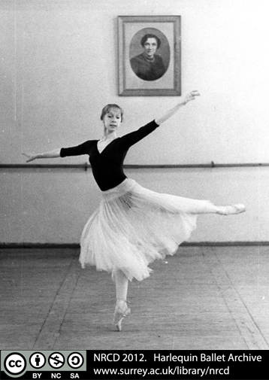  Image 1  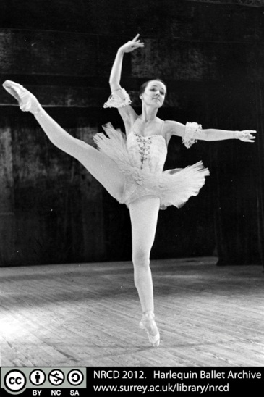  Image 2
Feedback | Both images show a raised gesture of arm and leg on the same side of the body, both elongate their spines and limbs in an upright position with their heads turned towards the front. The lifted legs reach outward while the supporting legs reach downward to the floor.  The main difference is that image 1, captures the dancer in movement where the points of opposition in her body and limbs enable her to balance with the weight a correctly aligned around the line of aplomb, passing from her toes to the centre of her body to her head. The dancer in image 2 seems to be lengthening the spine upwards and maintaining the shape while moving off the centre; the action captured in the picture does not show a vertical alignment through the supporting leg and foot.  Image 1 suggests that the dancer arrives at this ‘position’ and moment in space/time as part of a movement sequence. Image 2 suggests the dancer sustains the oppositions to hold the ‘position’ as it moves through space.  These images can also be seen as reflecting differences between a more Romantic style (image 1) and a Neoclassical style (image 2). This is evident in the flow of lines rather like water in image 1 and more staccato sharp quality in image 2 in which the dancer is falling away from the vertical line. Another stylistic clue is given by the type of the tutus. Later on you will have a chance to discuss aesthetic aspects and styles in ballet.

Task 6: Exploring inside and outside space

In this task you will develop a vocabulary for describing the feeling and experience between inside space and outside space that will help you to talk about what it feels to perform some ballet movements such as épaulement, battement tendu, éffacé, croisé, and écarté. In particular, you will be focusing on the definitions of these concepts through some reading and viewing activities as well as constructing together a map of images for all these movements.

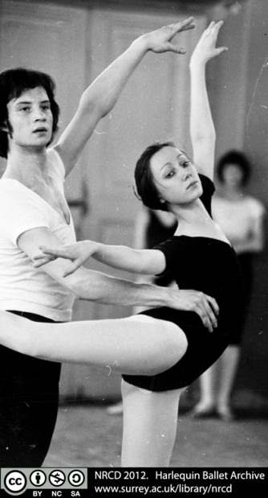

In class this week you will experiment with precise facing in different directions. Complete the following activities to prepare you for the classwork.

Activity 6.1

In this activity you are going to work on definitions of ballet terms.

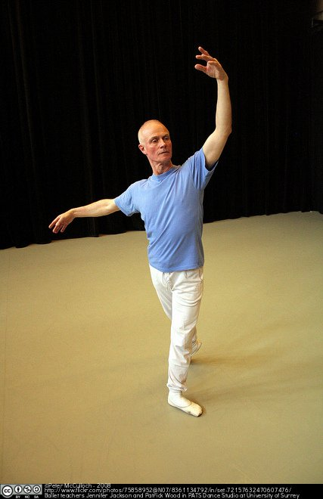

 | Matching1
Title
Text | Match these actions with their corresponding ballet terms.
Answer | The working foot slides from the first or fifth position to the second or fourth position without lifting the toe from the ground.
Answer | The dancer stands at an oblique angle to the audience so that a part of the body is taken back and almost hidden from view.
Answer | Separated, thrown wide apart. The dancer faces either one of the two front corners of the room.
Answer | A term used to indicate a movement of the torso from the waist upward, bringing one shoulder forward and the other back with the head turned or inclined over the forward shoulder.
Answer | The crossing of the legs with the body placed at an oblique angle to the audience.
Match | Épaulement
Match | Battement tendu
Match | Éffacé devant
Match | Croisé
Match | Écarté
Feedback | Épaulement: A movement of the torso from the waist upward, bringing one shoulder forward and the other back with the head turned or inclined over the forward shoulder.  Battement tendu: The working foot slides from the first or fifth position to the second or fourth position without lifting the toe from the ground.  Éffacé devant: The dancer stands at an oblique angle to the audience so that a part of the body is taken back and almost hidden from view.  Croisé: The crossing of the legs with the body placed at an oblique angle to the audience.  Écarté: Separated, thrown wide apart. The dancer faces either one of the two front corners of the room.  You can find all these descriptions of ballet actions in the American Ballet Theatre Online Dictionary (opens in a new window).

Activity 6.2

Now read these pages (pp. 57-62) in Paskevska’s text and take notes according to the instructions.

Paskevska, A. (2005) Ballet Beyond Tradition: The Role of Movement Concepts in Ballet Technique. New York and London: Routledge.

 | Textentry1
Title
Text | Compare Paskevska’s descriptions of ballet actions with the ones in the previous activity.  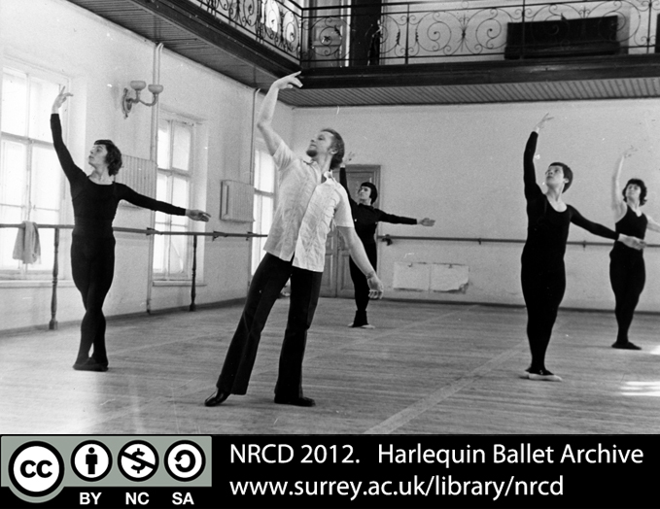
Feedback | Paskevska describes ballet actions in terms of feelings of opposition forces in the body of the performer. For example, she explains that in a tendu to the side the working leg reaches outward, the supporting leg opens the pelvis in the opposite direction and the foot reaches into the floor, the upper torso reaches upward and the sacrum downward; in an éffacé devant the upper body spirals moving the torso in opposition to the pelvis.  In the previous activity the dictionary entries were characteristic of traditional ballet descriptions where the emphasis is fundamentally on the space around the performer and the effect on the audience.  In your practice you should pay attention to the feeling of opposition inside your body but also to the space around you.

Activity 6.3

In this activity you are going to watch a video and apply some of the concepts you have learnt so far.

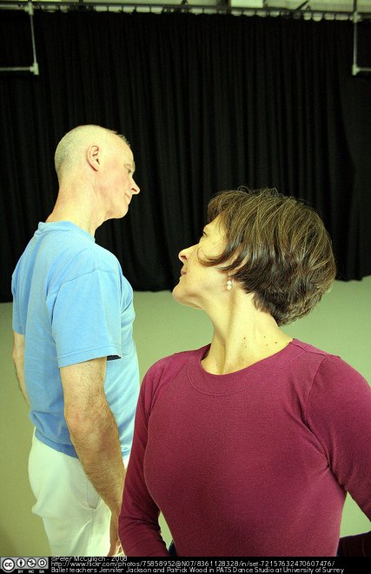

 | Textentry1
Title
Text | Watch the first 2 minutes of this video on the performance of Theme and Variations (opens in a new window) by the American Ballet Theatre and pay attention to how Balanchine uses in the opening sequence:  - moments of stillness and release.  - the interplay between croisé and éffacé.  Take notes of what you perceive in the movement.
Feedback | This is an elegant sequence in which dancer Gelsey Kirkland seems to stretch the time spent in the extension of the tendu so that the plié is released with elasticity; this gives the sequence breath and a bouncy quality as if the action is a rebound from the previous one. She and Baryshnikov use their heads differently. Kirkland maintains her focus to the audience which draws attention to the way that the shoulders freely rotate around the vertical to make easy transitions between croisé and éffacé lines. She steals a glance towards her partner just before he begins dancing. Baryshnikov’s performance is equally precise but his movements are broader and smoother. His gaze tends to follow the direction of the movement but his torso exhibits the same attention to the en face –the audience– in the croisé and éffacé. The woman’s balance has become more refined and elongated because of working on pointe.

Activity 6.4

Search on the internet for an image that illustrates one of these ballet concepts: épaulement, battement tendu, éffacé, croisé, or écarté. Add your image to the mind map “Attending to space in ballet”. Remember to add a detailed reference to your image.

Note: How to contribute to the mind map

First you need to create a new bubble (node) where to place your image:

1. Click on the term you want to illustrate, e.g. Battement tendu. The frame should turn blue.

2. Click on the “Plus” sign on the blue bar at the top. A new node or branch should appear.

3. Enter the name of the photographer, the date and the URL of your image.

Now you can add your image to your node:

4. Click on the “Properties” grey button on the top right hand side of the map.

5. In the section “Icons & Images” click on the down arrow on top of the word “Images”.

6. Select “Use web image”.

7. Select “Enter URL” and copy the location of your chosen image. Your image should now appear on the map.

If you need help, click on “help” icon on the blue bar at the top of the map and then choose “Online help”. Here you can find tutorials on how to edit the map. All you need to do for this activity is in the section “Basics”.

Task 7: Discussing descriptions and performances

In the previous task you have become aware of what is entailed and how it feels to perform some fundamental ballet movements and have thought about words to describe them. In the activities for this week you will be examining the concepts of musicality and rhythm.

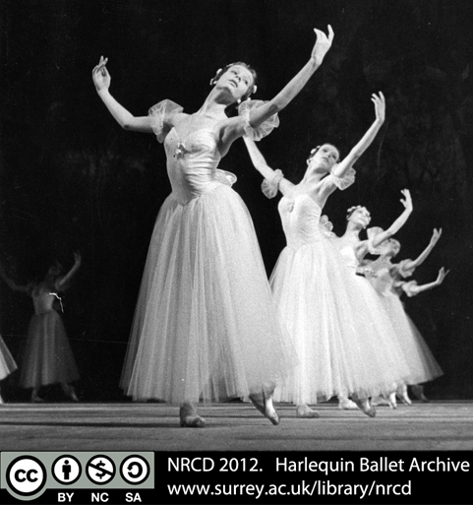

Activity 7.1

In this activity you are going to reflect on the meaning of the concept of “musicality”.

 | Textentry1
Title
Text | First, write a description of your own understanding of what musicality is.  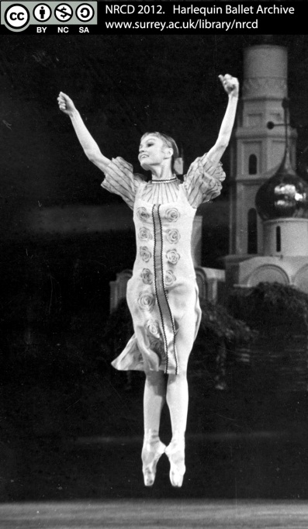
Feedback | This is an open answer. Responses will vary.  You can go to this online reference site Memidex (opens in a new window) to read various definitions of ‘musicality’ from different online dictionaries.

Activity 7.2

Read Tully’s text below and post your answers to these questions in the discussion thread “Musicality” in the module forum.

- Tully identifies music as “the prime mover in the dancer’s volition”, do you think this is always the case?
- Do you agree with the idea that all movement has a rhythm?
- Would you say that the dancer is like an instrument in the dance?
- Do these thoughts apply to all dance genres? Explain your responses.

“This […] indicates the prime mover in the dancer’s volition: the music. The time-space relation between movements has a rhythmical pattern suggesting music of its own. When this accords with the music, the two become one and the same. Then does the dancer experience ‘being danced’ the dance flows through him, the instrument, and his delight and the delight of the audience are one.”
(Tully, 2011, p. 23)

Activity 7.3

In this activity you are going to watch a video in order to attend to the use of space, time and music.

 | Textentry1
Title
Text | Watch again the first scene of the performance of Theme and Variations (opens in a new window) and this time pay attention to how Balanchine constructs:  - the relationship of the dancers to each other through the upper body and port de bras.  Where is there an accent or an applied emphasis in the physical action? How does this relate to the overall phrase of movement? How is this related to music?
Feedback | The gestures of the dancers’ upper body and port de bras reference both the audience and each other. They move towards and away from each other and in a figure of eight pattern that interweaves their positions in space. You might have been able to sense a downbeat or connection through the body with gravity (along the line of the aplomb).

Task 8: Understanding a battement tendu

This task will ask you to focus on how different authors describe a battement tendu.

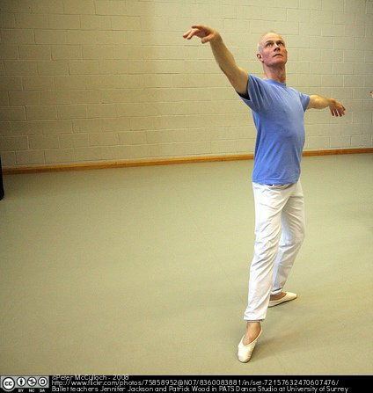

You will also have to demonstrate in practice the ballet concepts that you have engaged with during this semester.

Activity 8.1

For this activity you are going to describe with your own words a battement tendu.

 | Textentry1
Title
Text | Write a paragraph describing a battement tendu from the 5th position to the front (en avant) in the following terms:  - body parts involved,  - actual movement in space,  - distribution of weight,  - engagement of inner body structure and muscles.
Feedback | This is an open answer. In the texts that you will read next you will find descriptions of other authors about this movement.

Activity 8.2

Now read how Paskevska describes a battement tendu from the 5th position to the front and compare her description with yours by answering the questions below.

“[…] we know that the leg will end in an extension to the front of the body with the toes touching the floor. From the initial fifth position, the thigh begins to open outward and forward, and the toes gradually point until the instep is fully engaged. In order to remain placed over the supporting leg, a weight shift onto that leg is necessary. Further analyses leads [sic] us to question […] how the movement is facilitated by the rest of the body. Initially, we nurture these connections by keeping an elongated spine and an aligned pelvis. By engaging the spine and maintaining an upright pelvis, we ensure that the trapezius and the iliopsoas are optimally position to do their work.

[…] As with the legs, the arms require an engagement of the musculature without coercive tension. The arms, in addition to their expressive uses, act as stabilizers. They can also be distracters if they are not connected to the center. The muscles of the arms are designed to control the shape of the arms (with some exceptions, like the biceps, for example). The upper torso muscles control their raising and lowering (abduction and adduction). When this distinction is recognized, the arms can move without undue tension. […] in shaping the arms to the correct classical position by rotating the humerus inward and the lower arm outward the role of the arm in maintaining the shape can be isolated from the task of holding them up.

[…] The location of the center initially helps dancers to achieve connectedness”
(Paskevska, 2005, pp. 27-29)

 | Textentry1
Title
Text | - Have you included in your description the movement of the body parts mentioned here (body, spine, torso, arms, pelvis, thigh, leg, toes)?  - Have you made any references to the concept of control, tension, alignment, expression?  - Have you included any details that are missing in Paskevska’s description?  - How do you understand where the weight is placed when the tendu is as full extension?
Feedback | This is an open answer. Responses to these questions will vary.  Paskevska says that a shift of weight on to the supporting leg is indicated in the tendu. When you complete the next task, note what Tully teaches about the feeling of weight placement. Bring your questions and reflections about how to feel the weight in the tendu to class.

Activity 8.3

In this activity you will test your knowledge of a battement tendu en croix.

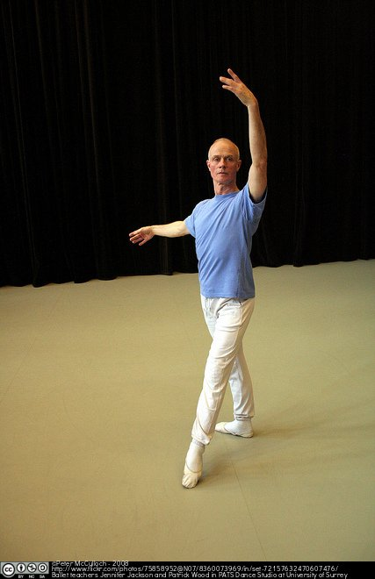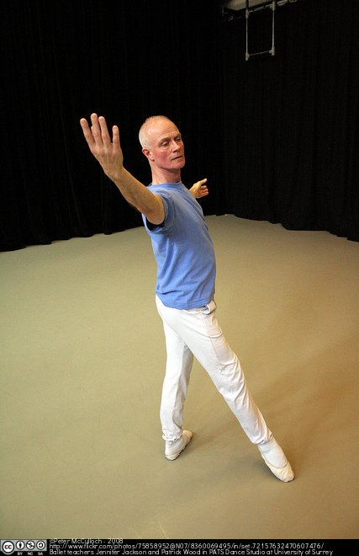

 | Gapfill1
Title | Battement tendu en croix
Text | Tully describes a battement tendu en croix from different positions of the feet. He identifies movement from the fifth position as “more complex” due to the crossing of the legs around the line of aplomb which can disturb the body’s placement.  Read carefully his description of this movement and type the appropriate body part for each gap: back, body, diaphragm, heel, leg, limbs, toes
Wordbank | back, body, diaphragm, heel, leg, limbs, toes
Answer | “It is essential to grasp that the impetus for battement tendu comes from the top of the [leg], and connects with the [heel]. It is the [heel] that leads into each en croix direction; the [leg] then stretches out, with the [heel] maintaining contact with the floor for as long as feasible. The action continues until only the [toes] remain in contact with the floor. The [leg] is now at a maximum extension from the centre. (…)  At no point during the battement tendu exercise should any weight be allowed to shift onto the working [leg], nor, on its reaching full extension, (…).  The pressure downwards through the supporting of [leg], and the lift through the [diaphragm] at the beginning and end of the battement tendu, will maintain the placement. Impetus for the movement is provided by an equal thrust down both [legs] and through the [feet]. (…)  To facilitate these extensions, the [body] inclines away from the direction of the movement, with a feeling of length to the front, width to the side, and up and forward (“up and over”) to the back. To the back, this will lend a slightly oblique line to the [body] and [leg]. Note that the movement upwards takes place before the movement forwards. It is a general rule that any movement about or away from the centre will be preceded by a feeling of lifting; this helps to stabilize the centre. As the [leg] closes, the [body] returns to the upright over its centre.  (…) Only through this up and over movement can the [limbs] and [back] maintain a true connection with the centre. (...).”  (Tully, 2011, pp. 43-47)
Feedback

Activity 8.4

In this activity you will watch a video on the training of the tendu in a class of professional dancers.

 | Textentry1
Title | Focus
Text | Watch the first 10 minutes this Royal Ballet daily class (opens in a new window) where they do a tendu exercise.  What do you notice about the different focus of the dancers in this class exercise and the performance of Theme and Variations?
Feedback | The dancers in class are concentrating on the mechanics of the action. There is almost no ‘play’ with expression through the épaulement. They practise speed in the working leg by maintaining the supporting side strongly – this is reflected in the performance of Theme and Variations. The focus in class in a professional ballet company is on constructing and tuning the instrument, especially at the barre which builds strength to that enables the dancer to move confidently through space.

Week 9: Describing through metaphors

Sometimes verbal metaphors capture powerful images that can help us understand movement better. In this task you will be evaluating some descriptions of ballet movement through metaphors and produce one yourself.

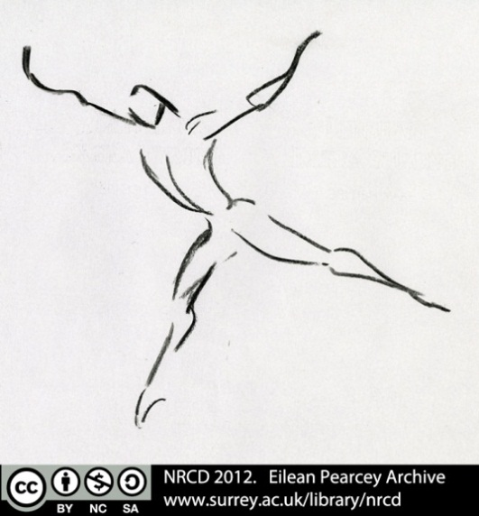

Activity 9.1

In her comments about teaching ballet, Paskevska emphasises the importance of training in addressing the mechanics of movement and making them work towards a specific aim. For this she offers a metaphor:

“[…] like a family engaged in cleaning the house together, each member is fulfilling a specific task”.
(Paskevska, 2005, pp. 27-29)

 | Textentry1
Title
Text | This metaphor of dance training is trying to portray a harmonious effective working of all body parts. Is a family cleaning a house together a good description of such a situation? How will you improve this metaphor?
Feedback | This is an open answer. Responses will vary.

Activity 9.2

In the following paragraph, Tully describes the control we need when dancing using the concept of water as a metaphor. Read the text and answer the question below.

“The movement of the dance cannot directly be controlled. If one takes water as an analogy, it will readily be seen that use and control of the water is through the channels, rivers and pipes, and that without direction and checks, water flows in all directions. So it is with the movement of the dance. Without the form, the positions and poses, there can be no control or proper direction of the responses to the music.”
(Tully, 2011, p. 23)

 | Textentry1
Title
Text | Do you think Tully’s metaphor for the movement of the dance is a useful one?
Feedback | This is an open answer. Responses will vary.

Activity 9.3

Now it is your turn to produce a metaphor.

 | Textentry1
Title
Text | Describe the movement of a tendu through your own metaphor.  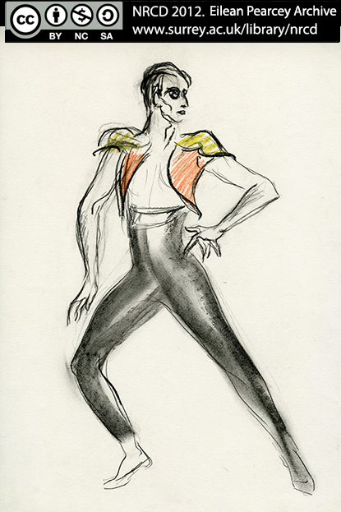
Feedback | This is an open answer. Responses will vary.

Week 10: Reflecting on your practice

Ballet is a dance form with a long tradition and its aesthetic and practice are constantly evolving. The texts you have read during this semester refer to the individual experience of dancing and to the fact that each dancer brings a personal set of ideas and pre-conceptions to the study of a dance genre. In this module you have been encouraged to develop a practice of ballet that is personal and contemporary as well as connected with the long tradition.

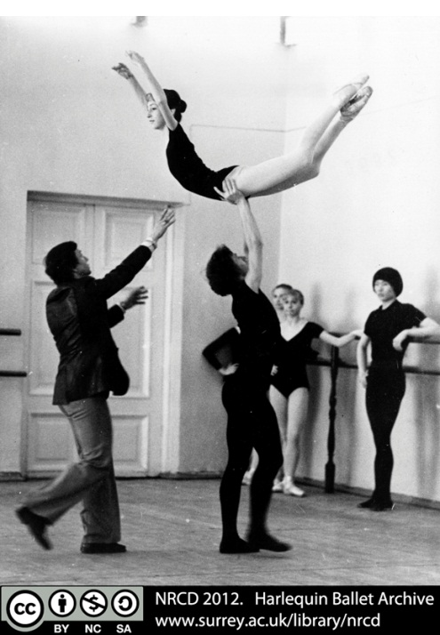

This week you are going to reflect on how your independent practice-based research, reading and analysis connect with your dancing in class.

Activity 10.1

Choose a quote from any of the texts you have read this semester that resonates with your experience of ballet or that inspires your ballet practice. Post your quote on the discussion thread “Inspiring quotes” in the module forum. Remember to indicate the author, date and page where your quote comes from.

Activity 10.2

In this final activity you will reflect on your own ballet practice.

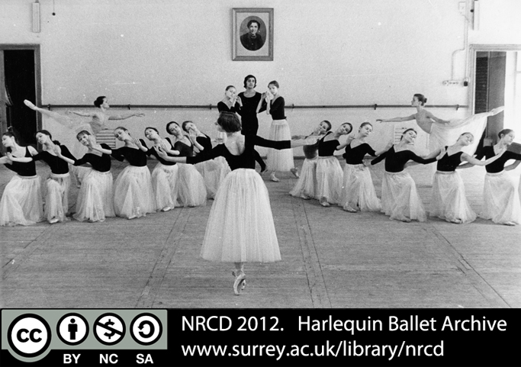

 | Textentry1
Title
Text | Write 3 bullet points about the ways in which your ballet practice is ‘truthful’, ‘correct’ and/or ‘good’ (refer to task 1 as necessary).
Feedback | This is an open answer. Your response should be personal.

Acknowledgements

Authors
This resource was created by Inma Álvarez and Jennifer Jackson, University of Surrey.

Critical reading by Amie S. Hawker.

Technical support by Rachel O’Callaghan, University of Surrey.

Images
Digitisation and CC licencing of images from the National Resource Centre for Dance at the University of Surrey has been done by Mike Reed. Here is a list of details of each image (links where applicable open in a new window) included in this package.

Introduction to the online tasks
Les Sylphides, Harlequin ballet. Photo by Unidentified. Available at the National Resource Centre for Dance at the University of Surrey. NRCD Ref: HB/F/2/50

Task 1
Jennifer Jackson and Patrick Wood prepare in PATS Dance Studio for a staff concert celebrating 25 years of academic study of dance at the University of Surrey. Photo by Peter McCulloch, 2008, available at:
http://www.flickr.com/photos/75858952@N07/8360062443/in/set-72157632470607476

Activity 1.1: Harlequin ballet Archive. Photo by Unidentified. Available at the National Resource Centre for Dance at the University of Surrey. NRCD Ref: HB/2/47

Activity 1.2: Jennifer Jackson and Patrick Wood prepare in PATS Dance Studio for a staff concert celebrating 25 years of academic study of dance at the University of Surrey. Photo by Peter McCulloch, 2008, available at:
http://www.flickr.com/photos/75858952@N07/8361141934/in/set-72157632470607476/

Task 2
Harlequin ballet Archive. Photo by John Gregory Collection. Available at the National Resource Centre for Dance at the University of Surrey. NRCD Ref: HB/F/1/8c

Activity 2.3: Harlequin ballet Archive. Photo by Unidentified. Available at the National Resource Centre for Dance at the University of Surrey. NRCD Ref: HB/F/1/12j

Activity 2.4: Harlequin ballet Archive. Photo by Unidentified. Available at the National Resource Centre for Dance at the University of Surrey. NRCD Ref: HB/F/2/131

Task 3
Jennifer Jackson and Patrick Wood prepare in PATS Dance Studio for a staff concert celebrating 25 years of academic study of dance at the University of Surrey. Photo by Peter McCulloch, 2008, available at:
http://www.flickr.com/photos/75858952@N07/8361144266/in/set-72157632470607476/

Task 4
Harlequin ballet Archive. Photo by Unidentified. Available at the National Resource Centre for Dance at the University of Surrey. NRCD Ref: HB/F/1/12a

Activity 4.1: Vitruvian Man by Leonardo da Vinci, c. 1487, pen and ink with wash over metalpoint on paper. Photo by Luc Viatour (8 September 2007), available at: http://www.flickr.com/photos/51369152@N00/3443283368/

Activity 4.2: Harlequin ballet Archive. Photo by Unidentified. Available at the National Resource Centre for Dance at the University of Surrey. NRCD Ref: HB/F/2/69

Task 5
Drawing by Eilean Pearcey. Available at the National Resource Centre for Dance at the University of Surrey. NRCD Ref: EP/Port2/un2

Activity 5.1: Harlequin ballet Archive. Photo by Unidentified. Available at the National Resource Centre for Dance at the University of Surrey. NRCD Ref: HB/F/2/32

Activity 5.2: Jennifer Jackson and Patrick Wood prepare in PATS Dance Studio for a staff concert celebrating 25 years of academic study of dance at the University of Surrey. Photo by Peter McCulloch, 2008, available at:
http://www.flickr.com/photos/75858952@N07/8361139596/in/set-72157632470607476/

Activity 5.3: Harlequin ballet Archive. Photo by Unidentified. Available at the National Resource Centre for Dance at the University of Surrey. NRCD Ref: HB/F/1/12b and HB/F/1/14a

Task 6
Harlequin ballet Archive. Photo by Unidentified. Available at the National Resource Centre for Dance at the University of Surrey. NRCD Ref: HB/F/1/8b

Activity 6.1: Patrick Wood prepares in PATS Dance Studio for a staff concert celebrating 25 years of academic study of dance at the University of Surrey. Photo by Peter McCulloch, 2008, available at:
http://www.flickr.com/photos/75858952@N07/8361134792/in/set-72157632470607476/

Activity 6.2: Harlequin ballet Archive. Photo by Unidentified. Available at the National Resource Centre for Dance at the University of Surrey. NRCD Ref: HB/F/1/5k

Activity 6.3: Jennifer Jackson and Patrick Wood prepare in PATS Dance Studio for a staff concert celebrating 25 years of academic study of dance at the University of Surrey. Photos by Peter McCulloch, 2008, available at:
http://www.flickr.com/photos/75858952@N07/8360067587/in/set-72157632470607476/
http://www.flickr.com/photos/75858952@N07/8361128328/in/set-72157632470607476/

Task 7
Harlequin ballet Archive. Photo by Unidentified. Available at the National Resource Centre for Dance at the University of Surrey. NRCD Ref: HB/F/1/12c

Activity 7.1: Harlequin ballet Archive. Photo by John Gregory Collection . Available at the National Resource Centre for Dance at the University of Surrey. NRCD Ref: HB/F/1/147

Task 8
Patrick Wood prepares in PATS Dance Studio for a staff concert celebrating 25 years of academic study of dance at the University of Surrey. Photo by Peter McCulloch, 2008, available at:
http://www.flickr.com/photos/75858952@N07/8360083881/in/set-72157632470607476/

Activity 8.3: Patrick Wood prepares in PATS Dance Studio for a staff concert celebrating 25 years of academic study of dance at the University of Surrey. Photos by Peter McCulloch, 2008, available at:
http://www.flickr.com/photos/75858952@N07/8360073969/in/set-72157632470607476/
http://www.flickr.com/photos/75858952@N07/8360069495/in/set-72157632470607476/

Task 9
Drawing by Eilean Pearcey. Available at the National Resource Centre for Dance at the University of Surrey. NRCD Ref: EP/Port3/un2

Activity 9.3: Drawing by Eilean Pearcey. Available at the National Resource Centre for Dance at the University of Surrey. NRCD Ref: EP/Port3/un3

Task 10
Harlequin ballet Archive. Photo by John Gregory Collection . Available at the National Resource Centre for Dance at the University of Surrey. NRCD Ref: HB/F/1/8g

Activity 10.2: Harlequin ballet Archive. Photo by Unidentified. Available at the National Resource Centre for Dance at the University of Surrey. NRCD Ref: HB/F/1/12e

Licence

This resource was released as an Open Educational Resource through the Contexts, Culture and Creativity: Enriching E-Learning in Dance project funded by JISC Strand A:Digitisation & Open Educational Resources.

All the activities and images are licensed under a Creative Commons Attribution-NonCommercial-Share Alike 2.0 UK: England & Wales Licence.

The JISC logo is licensed under the terms of the Creative Commons Attribution-Non-Commercial-No Derivative Works 2.0 UK: England & Wales Licence. All reproductions must comply with the terms of that licence.

The University of Surrey logo and the National Resource Centre for Dance logo are owned by the university and should not be produced without the express permission of the university.

