Laban Movement Analysis and Notation
  - Instructions for Students

Activity
Turn analysis from video clips for reflection.

Introduction
This activity is designed to give you an opportunity to practice and apply movement analysis, observational skills and documentation skills to film analysis. It will introduce you to digital archives as educational resources and will highlight the Digital Dance Archives at the University of Surrey.

It will take you approximately 1 hour.

Instructions
In this activity you will be analyzing turning movements from a video clip. You will make notes of your analysis and create a scrapbook to test your observational skills, reflect on them and share your analysis with others.

To complete this activity you need to:

- Go to the Digital Dance Archives website: http://www.dance-archives.ac.uk/
- Login and register in order to be able to make annotations:
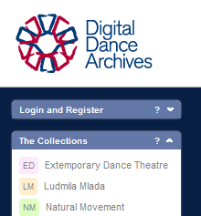

- Use the ‘Advanced Search’ button to find Siobhan Davies’ Rehearsal Scratch Tape 16 from the Series Eighty Eight.
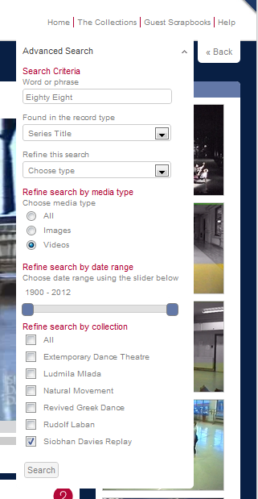

- Choose list view to see the list of available videos and go to page 2
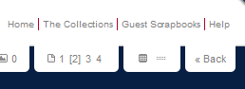

- Click on the image for a larger view.
- Watch the video once and identify when the dancer is turning.
- Watch the video again and use the ‘Add annotation’ tool to write down every time a turn is performed. Make a note of the amount of turn, level, body part and direction and of any other detail of the movement you might notice (e.g. 1/3 turn to the right with jump/ head gesture).
- Once you are happy with your annotation, create a scrapbook and save your video there by clicking onto the ‘Add to’ button.

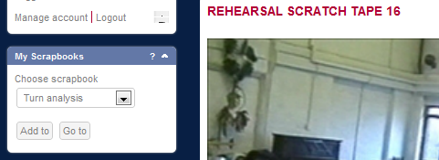

- Add to your scrapbook reflective notes on the process of analyzing from video vs. live observation and analysis. For instance, you can comment on point of view (i.e. facing direction of the performer; camera angle; artistic expression); quality of image (format of film; age of film); clarity of movement (what is clearly visible and what is not); or relationship of movers in time and space.

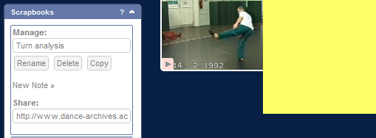

- Copy the URL link in the ‘Share’ area and send it to others in your group so they can see your scrapbook.

